
A Project Report on
FEDERATED LEARNING FOR DYSARTHRIA DETECTION: A COMPARATIVE STUDY ON TORGO AND UA-SPEECH DATASETS
in partial fulfillment of the requirements for the award of the degree of
BACHELOR OF TECHNOLOGY
In
COMPUTER SCIENCE AND ENGINEERING
Submitted by
PATNALA CHARAN SIMHA
21B91A05N3
Under the esteemed guidance of
Sri. T.V.K.P. Prasad
Assistant Professor


DEPARTMENT OF COMPUTER SCIENCE AND ENGINEERING
S.R.K.R. ENGINEERING COLLEGE (A)
ChinnaAmiram, Bhimavaram, West Godavari Dist., A.P.
[2024 – 2025]

DEPARTMENT OF COMPUTER SCIENCE AND ENGINEERING
S.R.K.R. ENGINEERING COLLEGE (A)
ChinnaAmiram, Bhimavaram, West Godavari Dist., A.P.
[2024 – 2025]
BONAFIDE CERTIFICATE

This is to certify that the project work entitled “FEDERATED LEARNING FOR DYSARTHRIA DETECTION: A COMPARATIVE STUDY ON TORGO AND UA-SPEECH DATASETS” is the Bonafide work of PATNALA CHARAN SIMHA, bearing registration number 21B91A05N3who carried out the project work under my supervision in partial fulfillment of the requirements for the award of the degree of Bachelor of Technology in COMPUTER SCIENCE AND ENGINEERING.

SUPERVISOR HEAD OF THE DEPARTMENT
(Sri. T.V. K. P. Prasad) (Dr. Bh. V. S. Rama Krishnam Raju)
Assistant Professor Professor

SELF DECLARATION

I hereby declare that the project work entitled “FEDERATED LEARNING FOR DYSARTHRIA DETECTION: A COMPARATIVE STUDY ON TORGO AND UA-SPEECH DATASETS” is a genuine work carried out by us in B.Tech. (C.S.E.) at SRKR Engineering College(A), Bhimavaram during 2024-2025 Academic Year and has not been submitted either in part or full for the award of any other degree or diploma in any other institute or University.

PATNALA CHARAN SIMHA
21B91A05N3

ACKNOWLEDGEMENTS
I sincerely express my gratitude to Sagi Ramakrishnam Raju Engineering College(A) for providing me with the opportunity to undertake this final year project, " Federated Learning For Dysarthria Detection: A Comparative Study on Torgo And UA-Speech Datasets ".
I extend my heartfelt thanks to our Prof. K.V. Murali Krishnam Raju, Principal, for fostering an academic environment that encourages research and innovation. I am also deeply grateful to Dr. Bh. V. S. Rama Krishnam Raju, Head of the Department of Computer Science & Engineering, for continuous support and motivation throughout this project.
A special thanks to my project supervisor, Sri. T. V. K. P. Prasad, Assistant Professor, whose guidance, technical expertise, and invaluable feedback have been instrumental in shaping this work. His mentorship has provided me with both knowledge and confidence to tackle challenges effectively.
I also appreciate the support of faculty members, technical staff, project teammates, family, and friends, whose encouragement and insights have been invaluable.

PATNALA CHARAN SIMHA
21B91A05N3

ABSTRACT
Dysarthria is a neurologic motor speech disorder that can substantially impair one's capacity to effectively communicate, which requires accurate early diagnosis for implementing timely intervention and effective speech therapy. Unfortunately, current clinical approaches depend on human judgment and inspection by trained speech-language pathologists, making the process subjective, time-consuming, and often hard to maintain on a routine basis, particularly where access to clinician expertise may be sparse. As a response to such challenges, this research recommends an AI-based system for automatic dysarthria detection using deep learning techniques for the analysis of speech data towards more objective and scalable assessments.
The methodology employs convolutional neural networks (CNNs) like AlexNet and ResNet-18 that are trained using log-Mel spectrogram features of raw speech signals to learn important acoustic characteristics of dysarthric speech. For data privacy and encouraging distributed model training, the system incorporates Federated Learning (FL) as well to enable decentralized model training on several client nodes without centralizing the sensitive medical information. This federated architecture facilitates cooperative model enhancement with maintenance of user privacy, and hence it is a strong candidate for real-world deployment in healthcare setups with multiple data sources.

SI No | CONTENTS |  |  | Page. No
 | ABSTRACT |  |  | i
 | CONTENTS |  |  | ii
 | LIST OF TABLES |  |  | iv
 | LIST OF FIGURES |  |  | v
 | LIST OF SYMBOLS |  |  | vi
1 | INTRODUCTION |  |  | 1
2 | LITERATURE REVIEW |  |  | 4
3 | PROBLEM STATEMENT |  |  | 11
4 | SOFTWARE REQUIREMENT SPECIFICATION |  |  | 13
 | 4.1 | PURPOSE |  | 13
 | 4.2 | SCOPE |  | 13
 | 4.3 | OBJECTIVES |  | 14
 | 4.4. | EXISTING SYSTEM |  | 14
 | 4.5 | PROPOSED SYSTEM |  | 15
 | 4.6 | REQUIREMENTS |  | 17
 |  | 4.6.1 | SOFTWARE REQUIREMENTS | 17
 |  | 4.6.2 | HARDWARE REQUIREMENTS | 18
5 | SYSTEM ANALYS & DESIGN |  |  | 19
 | 5.1 | SYSTEM ARCHITECTURE / METHODOLOGY |  | 19
 | 5.2 | DATASET |  | 22
 |  | 5.2.1 | FEATURES | 23
 |  | 5.2.3 | PRE-PROCESSING | 24
6 | IMPLEMENTATION |  |  | 39
 | 6.1 | TECHNOLOGIES USED |  | 39
 | 6.2 | MODULES IMPLEMENTATION |  | 40
7 | TESTING & RESULT ANALYSIS |  |  | 42
 | 7.1 | TEST CASES |  | 43
 | 7.2 | RESULT ANALYSIS |  | 44
8 | CONCLUSION & FUTURE SCOPE |  |  | 49
9 | REFERENCES |  |  | 50
10 | APPENDIX |  |  | 45
 | 1 | SAMPLE CODE |  | 52
 | 2 | SCREENSHOTS |  | 57

S. No. | LIST OF TABLES | Page. No.
Table 2.1 | Table Showing List of Papers reviewed in this project | 8
Table 4.1 | Table showing Software Requirements | 17
Table 4.2 | Table showing Hardware Requirements | 18
Table 5.1 | Table showing Model Parameters and values using Alex-Net Architecture | 27
Table 5.2 | Table showing Model Parameters and values using Res-Net Architecture | 30
Table 5.3 | Parameters of Ensemble Learning | 33
Table 5.4 | Voting Classifier Parameters | 36
Table 7.1 | Test Scenarios | 42
Table 7.2 | Test Cases with Input-Output Mapping | 43
Table 7.3 | Metrics Formulae Table | 44
Table 7.4 | Evaluation Metrics of Machine Learning Models for Image Analysis (UASpeech) | 45
Table 7.5 | Evaluation Metrics of Machine Learning Models for Image Analysis (TORGO) | 45

S. No. | LIST OF FIGURES | Page. No.
Figure 5.1 | Overall System Architecture | 19
Figure 5.2 | Dataset Distribution | 23
Figure 5.3 | AlexNet architecture | 25
Figure 5.4 | AlexNet architecture | 26
Figure 5.5 | Resnet Architecture | 28
Figure 5.6 | SVM (Support Vector Machine) | 32
Figure 5.7 | Random Forest | 32
Figure 5.8 | KNN(K-Nearest Neighbors) | 35
Figure 7.1 | Comparative Analysis of Machine Learning Models (UASpeech) | 46
Figure- 10.1 | UASpeech_Controlled_Result | 57
Figure 10.2 | UASpeech_Dysarthria_Uploading | 57
Figure 10.3 | UASpeech_Dysarthria_Result | 58
Figure 10.4 | Torgo_Controlled_Result | 58

LIST OF SYMBOLS
SYMBOL | DEFINITION
AUC | Area Under the Curve (associated with ROC)
CNN | Convolutional Neural Network
CPU | Central Processing Unit
FC | Fully Connected (Neural Network Layer)
GPU | Graphics Processing Unit
ROC | Receiver Operating Characteristic
SVM | Support Vector Machine
XGBoost | Extreme Gradient Boosting
LR | Linear Regression
KNN | K-Nearest Neighbors

INTRODUCTION
The accurate detection and continuous tracking of speech disabilities have become both a key challenge and a revolutionizing potential in the rapidly evolving fields of artificial intelligence and digital medicine. A motor speech disorder due to neurological damage that weakens or disables the muscles engaged in articulation, phonation, and speech generation, dysarthria is uniquely distinct among the other speech disabilities. This condition severely compromises an individual's ability to perform daily relationships and communicate well. It manifests itself as slurred, slow, or otherwise unclear speech. Several neurological conditions, including stroke, Parkinson's disease, cerebral palsy, multiple sclerosis, amyotrophic lateral sclerosis (ALS), and traumatic brain injury, are often associated with dysarthria. Since dysarthria is an incapacitating condition, early treatment, individualized treatment programs, and patients' quality of life improvement rely on its rapid and accurate identification and ongoing assessment.
In the past, speech-language pathologists' (SLPs') traditional techniques have been largely used to diagnose dysarthria. To determine the existence and severity of the illness, these experts use clinical observations, subjective rating scales, and perceptual assessments. Although these methods provide insightful clinical information, they are subjective by nature, subject to inter-rater variability, time-consuming, and demand a great deal of knowledge and resources. There is also an urgent need for automated, objective, and scalable diagnostic tools because manual assessments can be difficult to scale, especially for large populations or in underserved areas. This need has sparked a lot of interest in using developments in speech signal processing, deep learning, and machine learning (ML) to create novel tools for managing and detecting dysarthria.
Recent advances in speech signal processing, feature engineering, and classification methods have established a solid basis for developing automated systems that can precisely identify dysarthria. These methods use linear predictive coding (LPC), Mel-spectrograms, Mel-frequency cepstral coefficients (MFCCs), and other time-frequency spectral representations, among other auditory properties. These characteristics are crucial for identifying minute patterns and irregularities in speech signals that correspond to various degrees of dysarthric dysfunction. By examining these patterns, automated systems are able to distinguish between dysarthric and non-dysarthric speech and measure the disorder's severity, providing doctors with useful information for treatment planning.
To achieve high performance, the present work proposes an exhaustive and robust dysarthria detection system that integrates ensemble machine learning classifiers with state-of-the-art deep learning models. Using powerful convolutional neural networks (CNNs) such as AlexNet, ResNet, and VGG19 in combination with sequential models such as CNN-LSTM (Long Short-Term Memory) and recurrent neural networks (RNNs), the system's foremost intention is to extract and learn discriminative features from raw speech signals. Mel-spectrogram views of speech audio, that effectively compress important time-frequency domain information required for detailed speech analysis, are particularly appropriate for processing by such systems. High accuracy, generalizability, and insensitivity to various datasets and realistic environments are the objectives of the system, whose strengths in ensemble learning for classification and deep learning for feature extraction are combined.
Two of the recognized, publicly available datasets—the TORGO dataset and the UA-Speech dataset—are employed in thoroughly training and testing the proposed system. Audio recordings of vast sets of phonemes, words, and sentences uttered by matched control speakers as well as patients with dysarthria are encompassed in the TORGO dataset. The TORGO dataset presents ample information regarding investigating the variation and articulation of speech. UA-Speech dataset, however, offers a larger and more extensive set of dysarthric and non-dysarthric speech samples along with the corresponding annotations marking severity levels. This makes it ideal for both multi-class severity rating and binary classification (non-dysarthric/dysarthric). When used together, these datasets form the basis for training, validation, and testing models for the system, ensuring extensive testing across a variety of speech characteristics and impairment levels.
The project ensures data consistency along with quality through a meticulous processing stage for voice data. The preprocessing procedure comprises outlier detection followed by Mel-spectrogram extraction and feature amplitude normalization and input scaling to normalize dimensions for every model. Processed features are provided to different classification approaches beginning with Support Vector Machines (SVM), K-Nearest Neighbors (KNN), Random Forest and XGBoost and CatBoost. The proprietary ensemble classifier of the system enhances performance through prediction aggregation from various models achieved by weighted voting or stacking algorithms. Different classifiers used together with their complementary advantages produce this ensemble approach which both reduces individual classification deficiencies and raises overall predictive effect and dependable operation capacity.
This work includes one of its most inventive elements in the implementation of Federated Learning (FL) as an advanced method to protect privacy in distributed training. The decentralized model training feature of FL operates without a need to consolidate sensitive speech data from numerous edge devices holding compact silos of data. Pattern updates including weights and gradients serve as the only data exchanged between local devices enabling safe storage of raw patient information which adheres to privacy regulations such as HIPAA or GDPR. The proposed system utilizes FL to solve privacy concerns while allowing large-scale deployment for healthcare facilities that handle dispersed data throughout clinics and different devices and hospital entities. The strategy protects patient privacy by permitting various institutions to collaborate on knowledge acquisition.
The system performance goes through an extensive assessment using multiple evaluation metrics that include accuracy alongside precision as well as recall and F1-score and ROC-AUC measures alongside specificity. The metrics provide complete information about how well the system recognizes and rates dysarthria severity. The achieved results demonstrate promising potential for the system which appears favorable.
The ensemble models demonstrated remarkable classification accuracy of up to 98% on the UA-Speech dataset, with precision, recall, and F1-scores continuously above 0.94 for all important measures. This suggests that the capacity to differentiate dysarthric speech from non-dysarthric speech and categorize severity levels is incredibly reliable.

LITERATURE REVIEW
A detailed study about artificial intelligence detection of dysarthria severity levels using machine learning and deep learning models was published by AFNAN AL-ALI et al. [1]. A thorough examination of the research explored three speech databases including TORGO, UA-Speech and Nemours under various feature extraction strategies based on MFCCs and spectrograms and prosodic features. CNNs operated with MFCC features produced more than 95% accuracy in identifying dysarthric speech among normal voice patterns when using UA-Speech databases according to the study results. Hybrid CNN-LSTM models proved effective for understanding disordered speech characteristics through space and time when applied to various experiments with success rates from 91% through 95% accuracy. The accuracy rates obtained from SVM and Random Forests as classical ML models fell within 84%–88% when researchers used different datasets with changing features. The review established that deep learning models deliver the best performance with achieveable generalization but they need large datasets alongside substantial computational power.
Amlu Anna Joshy and Rajeev Rajan [2] examined dysarthria severity level classification through Deep Neural Networks (DNN), Convolutional Neural Networks (CNN) and Long Short-Term Memory Networks (LSTM) in their study. The analysis included Support Vector Machine (SVM) as baseline classifier against various deep learning models which used UA-Speech and TORGO datasets. The research team detected superior performance in dysarthria severity recognition by utilizing MFCCs in addition to their derivatives which served as inputs in their assessment of deep learning versus conventional machine learning. Manifold patterns in dysarthric speech could be successfully identified through deep learning architectures according to the evaluation of the CNN model which reached 96.18% accuracy on the TORGO dataset and 93.24% accuracy on the UA-Speech corpus. AI models demonstrate both diagnostic support ability and capability to create more precise automatic dysarthric speech recognition systems.
A novel automatic dysarthria detection system and severity level classification method was developed by Shaik Sajiha et al. [3] using Continuous Wavelet Transform (CWT)-layered Convolutional Neural Network (CNN) model design. The method consumes raw waveform data which the Amor Morse and Bump wavelets process to collect both time-series and frequency characteristics. The researchers evaluated the model using TORGO and UA-Speech datasets which are publicly accessible resources. Research indicates that the Amor wavelet delivered the best results compared to other wavelets while surpassing previous performance benchmarks of SVM and LSTM classifiers. The method showed effective noise reduction and improved generalization capabilities while omitting requirements for handcrafted features which sets it up as a promising tool for developing automatic real-time dysarthria screens.
Saska Tirronen et al. [4] worked to solve the data scarcity problem for multi-class voice disorder classification through assessments of three important methods including glottal source signal-based features (MFCC-glottal), self-supervised pre-trained models (wav2vec 2.0 and HuBERT) and hierarchical classification architecture systems. The Saarbrücken Voice Disorders (SVD) database served as the research basis to study three vocal disorder classes: healthy voices alongside hyperfunctional dysphonia and vocal fold paresis. The hierarchical classification methodology exceeded the performance levels of standard SVM techniques such as one-vs-one and one-vs-rest. When using a wav2vec 2.0 LARGE hierarchical model with fine-tuning the system achieved 62.77% accuracy accuracy for male subjects alongside 55.36% accuracy for females which amounted to a 15.76% and 6.95% absolute improvement over the baseline SVM classifiers. Glottal MFCCs generated better results for the identification of male speaker voices. The study demonstrates that using self-supervised learning with task-oriented infrastructure produces optimal results when handling voice disorder classifications in datasets with minimal data.
Amlu Anna Joshy et al. [5] performed an extensive assessment of dysarthria severity categorization through the combination of several acoustic signal characteristics and deep learning algorithms which included DNN, CNN, GRU, and LSTM. The research employed three experiments with both UA-Speech and TORGO databases as sources. Researchers employ MFCCs together with CQCCs and prosodic features while also making use of glottal and articulatory and phonetic features as well as i-vectors. The CNN models with MFCCs surpassed competing methods to achieve 93.27% accuracy on TORGO and 90.80% accuracy on UA-Speech in Experiment 1. Articulatory features provided the best performance in Experiment 2 while phonation features and prosodic features followed behind due to DNN classifiers demonstrating superior ability than SVMs. A two-stage DNN classifier implemented with i-vectors extracted from MFCC input achieved 93.97% accuracy when speaker-specific training was employed but only 49.22% accuracy when working independently of speaker information. The study demonstrated MFCCs delivered superior performance for identifying specific speakers but CQCCs demonstrated better functionality for unknown speakers. The research shows that i-vector-based DNN frameworks possess great potential with the requirement of extensive balanced datasets to improve model outcomes further.
The research by Anuprabha M. et al. [6] developed a dual-modality system which uses speech data together with textual information for performing dysarthria detection and severity analysis automatically. Previous research which utilized only speech features gained improvement with the introduction of a cross-attention mechanism for discovering connections between speech spectrograms and character-level text representations. The performance evaluation of the study was conducted through three experimental setups which involved speaker-dependent (SD) and both speaker-independent seen words (SID-1) and speaker-independent unseen words (SID-2) testing. The proposed multidimensional approach demonstrated superior performance compared to mono-speech methods because it attained 99.53% (SD) detection and 93.20% (SID-1) detection accuracy and 98.12% (SD) and 51.97% (SID-1) severity classification accuracy. The study shows that using text as linguistic guidance enables models to detect pronunciation abnormalities better since it strengthens dysarthria detection under clinical scenarios.
The authors Chen Zhang et al. [7] established a dysarthria detection solution for Parkinson’s Disease patients which used deep representation learning. A dataset containing speech samples from 600 subjects was built by the researchers who included both patients with Parkinson's Disease and participants without the condition. The available dataset included participants who varied by age along with dialects while performing word-reading and sentence-reading and essay-reading and free-talking tasks. Using WavLM as the base model combined with SA-CNN architecture for extracting features and making classifications in the proposed framework. The system produced an AUC value of 0.963 and reached a detection accuracy of 90.5% at the participant level which proved superior to traditional MFCC-based SVM or CNN models. Deep learning proves exceptional at processing sophisticated dysarthria acoustic signals from diverse and extensive real-world populations which demonstrates remote remote screening capabilities for Parkinson's speech disabilities.
The authors R. Vinotha et al. [8] developed a new method for Dysarthric Speech Recognition improvement through SepFormer-SEGAN speech enhancement with T-HAN and C-HAN recognition frameworks. The research employed multistage transfer learning through LibriSpeech initial training with subsequent fine-tuning on the UA-Speech corpus that contains speech samples from 19 dysarthric subjects with different degrees of dysarthria. A wide range of setups yielded remarkable performance improvements from the models which included unenhanced speech, enhanced speech through DSE + DSR and enhanced speech using both these methods along with data augmentation. The WRA score reached its peak at 84.07% using C-HAN with DSE and augmented data. Experimental findings show that joining adversarial speech enhancement technology with transformer-based architectural systems and multiple stages of transfer learning creates an effective solution for ASR systems used with dysarthric patients.
Dysarthria detection requires a hybrid approach that couples Convolutional Neural Networks (CNN) with Support Vector Machines (SVM) according to the research by Thilakarathne et al. [9]. The study demonstrates why early and accurate diagnosis of dysarthria is essential because neurological conditions and population aging have increased its frequency among patients. The designed model operates on audio signals to automate dysarthric speech classification. By combining deep learning features from CNN with traditional classifier strength from SVM the proposed method reached 98.25% classification accuracy that exceeded other approaches for pathological voice examination. Telluric shows that combining AI technology enables quick diagnostic progress which provides reliable scalable support to clinical staff when identifying motor speech disorders in medical settings.
Navod Neranjan Thilakarathne et al.[10] developed a modern deep learning architecture to detect dysarthria along with identifying dysarthric speakers by directly processing natural speech waveforms free of human intervention for feature engineering. The proposed framework includes a SincNet layer with distinctive initialization methods that use Mel, Erb and Bark scales to help it fit better to human speech characteristics. The Bark scale initialization achieved the highest effectiveness because it matches how humans perceive sounds through their ears. The optimized model delivered 97.0% accuracy for DD and 88.0% accuracy for DSI through its Bark scale configuration surpassing standard benchmark models. This model fits well in real-world applications because its end-to-end structure along with its ability to detect noise enables effective remote screening applications.
The research by Virginie Roland et al. [11] evaluated vowel articulation patterns for detecting dysarthria in Parkinson’s disease before symptoms emerge. The researchers performed acoustic measurements on sustained vowel productions /a, i, u/ from 63 PD subjects with dysarthric speech (43 subjects) and 20 PD subjects without dysarthria along with 35 controls. They used three acoustic parameters including triangular vowel space area (tVSA) and vowel articulation index (VAI) and the PHI index. Findings demonstrated the utility of tVSA and VAI to separate PD patients with dysarthria from healthy controls yet the PHI index performed best for PD speakers without dysarthria. This research demonstrates that evaluation of PHI functions as an effective early acoustic tool to measure PD-related deterioration in speech motor control before objective dysarthria symptoms develop.
The automatic assessment of dysarthria severity got introduced through an innovative technique based on bi-modal Audio-Visual Vowel Graph Attention Network (AV-VGAN) which Xiaokang Liu and his team [12] presented. The technique unites acoustic and visual expert features using graph neural networks based on vowel space theory framework. The researchers employed data from 87 post-stroke dysarthric and healthy individuals from the MSDM database to create their vowel-based data augmentation strategy and specialized graph attention structure that analyzed vowel spatial relationships. Experimental evaluation confirmed the superiority of AV-VGAN as an assessment tool by delivering an RMSE measurement of 11.12 accompanied by an R² value of 0.78 when predicting FDA scores. The research shows that modeling vowels together with audio-visual information improves dysarthria evaluation accuracy and interpretability when working with limited assessment data.
According to Gennaro Tartarisco et al. [13] the Hierarchical Machine Learning Model (HMLM) assessed dysarthria severity in early-onset ataxia children by analyzing audio from PATA task recordings. This study included 55 participants made up of 18 healthy subjects and 37 ataxia patients who underwent two-class binary categorization between healthy and patient populations as well as low and high dysarthria severity levels. At the first level the system applied conventional features alongside machine learning models before deep features extracted from a pre-trained VGGish CNN were used at the second level. Through the Hierarchical Multi-Level Method analysis achieved 90% accuracy for differentiating between patients and healthy controls while reaching 80% success for severity assessment which exceeded flat multi-class modeling results. The research demonstrates that combining classical and deep learning features through hierarchical approaches offers an effective solution for clinicians to screen and monitor speech disorders in pediatric ataxia patients.
TABLE 2.1: Table showing List of papers reviewed in this project
Reference Number | Authors | Dateset Used | Models Used | Results Obtained | Limitations
[1] | Afnan Al-Ali, Rani Chinnappa Naidu, Somayaal Maadeed et al. | TORGO Dataset  UA-Speech Dataset  Dysarthria Database | CNN,  RNN,  Long Short-Term Memory (LSTM) | Highest Accuracy of all models: 85% | 1)Lack of large-scale, diverse datasets, imbalanced datasets.  2)Variability in speaker data.
[2] | Amlu Anna Joshy, Rajeev Rajan | UA-Speech Corpus,TORGO Database | DNN, SVM,  CNN | TORGO Dataset:  96.18%  UA-Speech :  93.24% | 1)GeneralizationPerformance might vary across datasets or real-world settings.  2)Data-dependency
[3] | Shaik Sajiha, Kodali Radha, DhulipallaVenkata Rao et al. | TORGO and UA-Speech datasets | CWT-layered CNN model | TORGO Dataset:  88%  UA-Speech Corpus:  97% | 1)Limited Real-World Evaluation  2)Generalization Across Languages or Disorders
[4] | Saska Tirronen, Sudarsana Reddy Kadiri, Paavo Alku | Saarbrücken Voice Disorders (SVD) Database  Includes 71 voice disorders. | 1)SVM,Naïve Bayes, wav2vec | Fine-tuned wav2vec-LARGE-hier Male -62.77 | 1)Non-nested cross-validation used  2)Gender-based performance difference
[5] | Amlu Anna Joshy, Rajeev Rajan | UA-Speech Corpus: 13 healthy + 19 dysarthric speakers.  TORGO Database: 7 healthy + 8 dysarthric speakers | 1)DNN 2)CNN  3)vector extraction (MFCC, CQCC) | DNN + iMFCC (UA-Speech): 93.97%  CNN + MFCC (TORGO): 93.27% | 1)Speaker Overfitting  2)Dataset Imbalance:  3)Limited Subjects
[6] | Anuprabha M, Krishna Gurugubelli  , Kesavaraj V  , Anil Kumar Vuppala | UA-Speech Database  15 dysarthric speakers and 11 healthy speakers | 1)Speech Encoder: 2D CNN layers + Bi-GRU  2)Text Encoder:  3)Cross-Attention Mechanism: Merges speech and text embeddings | Dysarthria Detection:  SD: 95.38% | 1)Performance Drop in SID-2 Detection:  Accuracy slightly decreased from 87.76% to 85.30%.  2)Text Input Dependency:  this may limit deployment in real-time or noisy environments.  3)High Resource Training
[7] | Chen Zhang, Chen Gong,Yanan Sui | 600 total (300 Parkinson’s Disease patients, 300 healthy controls)  Remotely via phone using the same equipment and conditions | MFCC + SVM  MFCC + CNN  MFCC + SA-CNN-FC | AUC  MFCC + SVM : 0.706  MFCC + CNN : 0.795  MFCC + SA-CNN-FC: 0.819 | 1)Language and Dialect Bias: Speech data collected only in Chinese; performance across other languages or multilingual datasets is not evaluated.
[8] | R. Vinotha, D. Hepsiba, L. D. Vijay Anand, J. Andrew & R. Jennifer Eunice | UA-Speech: 19 dysarthric speakers, various intelligibility levels (2%–95%), 765 words per speaker. | S-SEGAN (SepFormer + SEGAN): For speech enhancement.  T-HAN ( | Transformer: 76.47%  Conformer: 79.20%  T-HAN: 82.13%  C-HAN: 84.07% (highest) | 1)Limited availability of diverse dysarthric speech data.  2)Complexity and variability in dysarthric speech patterns.
[12] | Xiaokang Liu, Xiaoxia Du, Juan Liu, Rongfeng Su, Manwa Lawrence Ng, Yumei Zhang, Yudong Yang,  Shaofeng Zhao, Lan Wang | MSDM Database | AV-VGAN (Audio-Visual Vowel Graph Attention Network) | Best Model (AV-VGAN with cross-attention):  RMSE: 11.12  R²: 0.78 | 1)Limited linguistic generalization  2)Visual features limited to lip regions; may not capture full facial dynamics

PROBLEM STATEMENT
Dysarthria detection presents itself as a fundamental barrier in the advancement of automated clinical speech assessment systems that aim to support neurological diagnostics and personalized speech therapy. This disorder, caused by neuromuscular damage, disrupts articulatory coordination and severely impacts speech intelligibility. Traditional evaluation methods rely on subjective observations by speech-language pathologists (SLPs), which suffer from limited scalability, potential inconsistency, and time inefficiency—especially in large-scale or remote clinical settings.
Earlier approaches to automate dysarthria detection employed handcrafted acoustic features such as MFCCs, pitch variation, and spectral energy fed into classical machine learning classifiers including SVMs and Decision Trees. While offering a step forward, these systems are constrained by the dependency on manual feature engineering, inadequate generalization across diverse speakers, and insufficient robustness in clinical settings with high inter-subject variability.
Recent advances propose the use of deep learning on Mel spectrograms, which convert speech waveforms into 2D time-frequency visual representations that are better suited for convolutional neural network (CNN) analysis. Models like AlexNet and ResNet, when trained on these images, can extract hierarchical features relevant to articulation, rhythm, and clarity of speech. The UASpeech and TORGO datasets, both publicly available and widely used in dysarthria research, offer labeled recordings spanning four severity categories: Normal Speech, Mild, Moderate, and Severe Dysarthria. In this work, we utilize the Kaggle Dysarthria Detection Dataset, derived from these corpora, to build a robust and scalable severity classification model.
Researchers aiming to build accurate dysarthria assessment models encounter multiple core challenges:
- High-dimensional Data Representations
Speech signals, when transformed into spectrograms, result in high-dimensional image matrices (224×224 pixels in this study) requiring sophisticated convolutional processing to learn discriminative speech patterns without overfitting.
- Speaker Variability and Limited Samples
Individuals with dysarthria exhibit significant variability due to differing neurological impairments and speech conditions. Combined with relatively limited labeled data, this poses generalization issues. This work applies normalization techniques (StandardScaler) and model tuning to combat this.
- Imbalanced Class Distributions
The existing samples of Dysarthria datasets create significant imbalances due to rare occurrence of "Severe" cases. The unequal distribution of training data produces biased predictions until Synthetic Minority Over-sampling Technique (SMOTE) is used for correction.
- Underperformance of Single-model Systems
Classical and standalone models (e.g., SVM, RF, KNN) achieve modest accuracy (92–94%) and struggle to model complex speech irregularities. Ensemble learning techniques are necessary to combine complementary decision patterns across different classifiers.
- Need for Model Interpretability and Clinical Applicability
Deployable systems in healthcare demand not only high accuracy but interpretability and real-time inference support. Deep learning pipelines require structured design and validation to be suitable for medical usage.
This research addresses these challenges by building an ensemble-based speech classification system that integrates CNN-based feature extraction with multiple machine learning classifiers including CatBoost, XGBoost, and Random Forest, fused using strategies such as meta-model stacking (RF + GBC → LR) and weighted soft voting (SVM + RF). The ensemble achieved superior accuracy of 98% on UASpeech and 94.5% on TORGO, significantly outperforming standalone models.
The main objective focuses on developing a deep learning structure which can reliably identify dysarthric speech severity at clinical accuracy standards for enhancing automated speech disorder evaluation systems. The established method provides scalable and real-time objective solutions for dysarthria detection which ought to expand AI applications in neuro-speech diagnostic settings.
.

SOFTWARE REQUIREMENT SPECIFICATION
4.1 PURPOSE
An advanced software system development establishes its core objective to create a system which correctly identifies dysarthria impairment severity through deep learning speech processing methods. Acoustic and articulatory features become extractable through convolutional neural networks along with AlexNet and ResNet after the system transforms speech recordings into Mel spectrogram images. Clinical patterns within the dataset serve as the basis to categorize speech samples into the severity levels Normal, Mild, Moderate, and Severe.
Traditional dysarthria assessment methods depend primarily on speech-language pathologist evaluations that consume significant time along with being subjective while underperforming in systemwide healthcare environments. The generalization abilities and capacity to understand dysarthric speech complexity undermine classical machine learning techniques because their operation relies on manual features extraction.
Dysarthria severity detection through this system uses automated spectrogram analysis with ensemble learning strategies that implement meta-model stacking and hybrid classifiers as detectors. This system shows promising capabilities for assisting intelligent healthcare technologies which specifically benefit clinical neurology applications and telemedicine services and digital speech rehabilitation software systems.
4.2 SCOPE
All development processes start from data preprocessing and end at model evaluation while creating a deep learning-based dysarthria severity classification system. The system works with pre-recorded speech data that undergoes a transformation into Mel spectrograms for handling by deep learning models that utilize image-based formats. The selected CNN architectures require inputs with 224×224 pixel resolution and normalization to process all spectrogram images.
The classification task categorizes dysarthria severity into four established sections: Normal (0) Rather Mild (1), Moderate (2) Together with Severe (3), which corresponds to the provided speech data labels. Data loading forms the basis for preprocessing operations followed by spectrogram transformation then resizing and normalization. Relief of the dataset's class imbalance happens through class-balancing techniques that promote balanced training among all severity levels.
Two fundamental convolutional neural networks called AlexNet and ResNet receive training as new models to extract discriminative features from spectrogram images. The features extracted from the new set of data are sent to K-Nearest Neighbors (KNN) as well as Support Vector Machine (SVM), Random Forest (RF), CatBoost, and XGBoost machine learning classifiers for their evaluation process. Multiple ensemble methods were developed for the classification stage including RF together with GBC as input for Logistic Regression models while GBC and AdaBoost were combined for an ensemble and SVM and RF used weighted soft voting ensemble.
Multiple accuracy-based performance metrics and precision-specific metrics as well as recall-based metrics and F1-score, ROC-AUC and specificity are analyzed during evaluation for two benchmark datasets UASpeech and TORGO. UASpeech ensemble reached a best-run with 98% accuracy and 99% F1-score but CatBoost obtained 94.5% accuracy on TORGO. Loss and accuracy visualization tools from different epochs help to track training convergence in addition to other visual monitoring features
4.3 OBJECTIVES
This project establishes design and execution of an effective data security infrastructure for dysarthria detection through deep learning and federated learning algorithms. The key objectives include:
1.A comparison of traditional machine learning models including KNN, SVM, Random Forest, XGBoost, and CatBoost will occur to identify dysarthria from TORGO and UA-Speech data.
2.The project develops deep learning models (AlexNet and ResNet-18) from log-Mel spectrogram speech features to evaluate their ability in identifying spectral-temporal dysarthria patterns.
3.The research evaluates traditional ML modules against CNN-based methods on their accuracy levels and generalization properties alongside data robustness evaluation.
4.The goal is to build a simulation of Federated Learning (FL) that allows multiple entities to work together on model development without exchanging speech data contents which keeps sensitive information protected.
5.A controlled evaluation of the Federated Averaging (FedAvg) algorithm would analyze its performance characteristics regarding multi-client setups as well as determine its convergence abilities and communication efficiency.
6.An assessment of the benefits and restrictions that medical speech applications face with federated learning will determine whether decentralized dysarthria detection functions in real medical settings.
7.This research fills the gap by performing a comprehensive analysis between centralization and federalization on diverse benchmark datasets which will advance secure large-scale healthcare AI systems.
4.4 EXISTING SYSTEM
Researchers have examined automatic detection of dysarthric speech through traditional machine learning and deep learning methods in existing research studies. Current detection systems mainly depend on data centralization methods to gather and process patient data from a solitary training server. The three prevalent classifiers utilized for dysarthria detection include Support Vector Machines (SVM) along with Random Forests and K-Nearest Neighbors (KNN) which work with acoustic features consisting of MFCCs or spectrograms.
Research in recent times employs CNNs such as AlexNet and ResNet for identifying speech disorders by processing spectrogram images. The developed models show excellent capabilities to detect intricate speech variations while achieving outstanding results when working with dysarthric speech. The centralized nature of most deep learning systems triggers privacy-related concerns because patient data remains vulnerable when protected in this manner particularly within healthcare practices.
Existing research mainly concentrates on two datasets TORGO and UA-Speech while their validation scope extends only to individual datasets. These systems do not generalize well beyond their training boundaries and this prevents their practical use across multiple institutions requiring integrated diagnostic settings.
Most current research fails to study how federated learning could detect dysarthria while maintaining distributed training operations between data clients. Current research shows a deficiency in systematic analysis between centralized and federated methods for dysarthria detection systems.

4.5 PROPOSED SYSTEM
The proposed system establishes a strong and privacy-focused framework for dysarthria detection through deep learning combined with federated learning technical methods. The system features two major operational sections known as centralized training and federated learning simulation. The approach achieves high model performance and protects patient privacy at the same time.
1. Data Preprocessing and Feature Extraction
- Raw audio recordings from TORGO and UA-Speech datasets are preprocessed.
- Log-Mel spectrograms function as input data for all traditional and deep learning models used in this project.
- The data requires image transformation techniques including resizing and normalization to fulfill CNN input requirements since it needs to operate at (227×227×3).
2. Traditional Machine Learning Classifiers
- The baseline models KNN, SVM, Random Forest, XGBoost and CatBoost use handcrafted features during their training process.
- These models provide a performance benchmark for comparison with deep learning architectures.
3. Deep Learning Models
- Two convolutional neural networks are implemented:
  - AlexNet: The researchers developed AlexNet which became a specialized architectural design with five convolutions and fully connected layers.
  - ResNet-18: A deep residual network that leverages skip connections to avoid vanishing gradients and enhance feature learning.
- The models use TORGO and UA-Speech datasets for training purposes to assess their classification capabilities.
4. Federated Learning Simulation
- The research implements a simulation of Federated Learning (FL) to model distributed training environments consisting of hospitals together with rehabilitation centers.
- The data splits up between different clients who operate autonomously for model training using their individual proprietary data.
- The central server performs Federated Averaging (FedAvg) algorithm operations to combine model parameters into a global framework.
- The method repeats across multiple rounds to optimize the model model as information exchanges exclusively through aggregated parameters instead of actual client data to ensure privacy protection.
5. Evaluation and Comparison
- A set of evaluation metrics includes accuracy together with loss measurements and convergence speed testing.
- A comparative analysis is conducted between:
  - Centralized CNN models vs. traditional ML models
  - AlexNet vs. ResNet-18
  - Federated learning vs. centralized training

4.6 REQUIREMENTS
To achieve successful development for the multimodal emotion recognition system it requires the specific software and hardware resources described here.
    - Software Requirements
Table 4.1: Table showing software Requirements
Category | Details
Operating System | Windows 10/11, Ubuntu 20.04 LTS or above
Programming Language | Python 3.8 or higher
Development Environment | Jupyter Notebook / VSCode / PyCharm
Libraries & Frameworks | TensorFlow 2.x, PyTorch 1.9 or higher, Scikit-learn, Librosa, Matplotlib, Seaborn, Pandas, Numpy, XGBoost, CatBoost, tqdm
Special Modules | torch.hub (for loading AlexNet), tensorflow.keras.applications (for ResNet50)
Datasets | TORGO Dataset, UA-Speech Dataset (pre-downloaded and organized)
Model Architectures Used | AlexNet (Feature Extraction), ResNet50 (Transfer Learning), KNN, SVM, Random Forest
Category (ML) | XGBoost, CatBoost, Ensemble Methods
Version Control | Git (optional for collaboration)

    - Hardware Requirements
Table 4.2: Hardware Requirements
Category | Specification
Processor (CPU) | Minimum: Intel i5 (8th Gen) or AMD Ryzen 5
Processor (CPU) | Recommended: Intel i7/i9 or AMD Ryzen 7/9
Graphics Card (GPU) | Minimum: NVIDIA GTX 1050 Ti (for small batches)
Graphics Card (GPU) | Recommended: NVIDIA RTX 2060/3060 or higher (for faster training)
RAM | Minimum: 8 GB
RAM | Recommended: 16 GB or higher
Storage | Minimum: 100 GB free space
Storage | (Datasets + Intermediate Feature Files + Model Checkpoints)
Other Hardware | - High-speed SSD recommended for faster dataset loading.
Other Hardware | - Headphones (optional for manually verifying audio samples).
Internet | Required for downloading pre-trained models (e.g., ResNet50 from Keras Applications, AlexNet from PyTorch Hub) and libraries installation.

SYSTEM ANALYSIS & DESIGN
5.1 SYSTEM ARCHITECTURE / METHODOLOGY
Input speech datasets TORGO and UASpeech

Convert to Mel spectrograms

Resizing
Rescaling

Preprocessing

Feature Extraction using Alexnet and Resnet 50
Test Data

Train Data

SVMM
CatBoost
CNNNN
RF
KNN

Voting Classifier :97%

Evaluation Metrics

Classification Result

Figure 5.1: Overall System Architecture
The research design for developing the dysarthria severity classification system through speech signals is presented in detail in this section. Through the CNN-based method the architecture performs a smooth transition of raw audio files toward classification of severity levels.
The beginning of the process triggers when raw speech signals enter the system after their transformation into Mel spectrograms as Figure 5.1 shows. The preprocessing steps refine spectrograms to make them more uniform before enhancement. The spectrograms generated through the process become arranged in an image datastore that functions as an orderly data collection system for training and testing operations.
The CNN model receives processed data during training to understand distinct features of dysarthria severity categories. The testing period engages the model to classify untested speech samples. The core position in the proposed architecture belongs to the CNN model which receives input data for analysis and outcome prediction.
The system provides a classification result after inference that classifies dysarthria severity across four levels:
- Normal (Normal Speech)
- Mild (Mild Dysarthria)
- Moderate (Moderate Dysarthria)
- Severe (Severe Dysarthria)
This structured pipeline ensures a systematic transformation from raw auditory signals to clinically relevant severity labels, contributing to automated diagnosis and potential early intervention in speech disorders.
A systematic experimental process served to assess the effectiveness of machine learning models when judging image-based speech disorder data from the UASpeech and TORGO datasets. The method includes data modification steps before selecting models for training followed by evaluation through performance assessments.
1. Data Collection and Preprocessing : Two publicly available datasets—UASpeech and TORGO—were utilized. These datasets consist of speech-related visual data representing various levels of dysarthria. Preprocessing steps included:
- Noise removal and image normalization
- Segmentation to focus on relevant speech-related features
- Feature extraction using relevant statistical and domain-specific techniques
- Label encoding and data balancing to address class imbalances
- The dataset requires division into training and testing sections with a standard proportion of 80-20.

2. Model Selection :
Several types of both traditional and advanced machine learning algorithms were used for identifying appropriate models for the task.:
- The baseline models used both Random Forest (RF) as well as K-Nearest Neighbors (KNN).
- Advanced models: Support Vector Machine (SVM), XGBoost, CatBoost
- Ensemble approaches:
  - Hybrid Ensemble 1: Random Forest + Gradient Boosting Classifier + Logistic Regression
  - Generic Ensemble 2: Voting or averaging combination of top-performing models
3. Training and Hyperparameter Tuning :
A training process applied both datasets by feeding them to each model. The model's performance depended on selecting the main parameters through grid search and cross-validation techniques to enhance system reliability. Standard cross-entropy loss functions served as training performance metrics during which gradient-based optimization methods applied their calculations.
4. Evaluation Metrics :
Performance evaluation included a full range of metrics which enabled assessment across different operating dimensions:
- Accuracy
- Precision
- Recall (Sensitivity)
- F1 Score
- AUC-ROC
- Specificity
- Cohen’s Kappa
- Matthews Correlation Coefficient (MCC)
- Training and Testing Loss
The formulas and definitions of these metrics are summarized in Table 1 of the results.
5. Comparative Analysis :
Performance was compared across models for both datasets. Special emphasis was given to:
- The superiority of hybrid ensembles on UASpeech, where the RF + GBC + LR ensemble achieved the highest performance (up to 99% F1 Score).
- The relatively uniform performance across models in TORGO, where CatBoost emerged as the top model with 95% precision and 94.5% ROC-AUC.

6. Visualization :
Comparative results were visualized (Figures 7 & 8) to clearly illustrate model strengths and weaknesses across datasets and metrics.
5.2 B. DATASET
i. Source
The datasets used are dedicated to dysarthric speech recognition and analysis, sourced from Kaggle at https://www.kaggle.com/datasets/aryashah2k/noise-reduced-uaspeech-dysarthria-dataset and https://www.kaggle.com/datasets/pranaykoppula/torgo-audio.They provide comprehensive collections of noise-reduced and raw speech samples from individuals with dysarthria as well as control subjects, captured through structured recording protocols. These datasets facilitate research and insights into speech impairment detection and classification using deep learning and machine learning algorithms.
ii. Description
The project uses TORGO and UASpeech datasets as major speech databases that were built specifically to aid dysarthric speech recognition research and disease detection and audio processing studies.
TORGO Dataset
The Department of Computer Science at the University of Toronto compiled the TORGO database into a recognized tool for pathological speech examination. The database contains audio recordings of people exhibiting dysarthria and those without this motor speech disorder type due to neurological damage. The organization of TORGO database relies on four specific categories that include speaker gender along with health condition and recording session and microphone type.
Structure:
- F_Con: Female control group (without dysarthria)
- F_Dys: Female dysarthric speakers
- M_Con: Male control group (without dysarthria)
- M_Dys: Male dysarthric speakers
Each speaker is assigned a unique identifier (e.g., FC01, M03) and recordings are segmented by sessions (S01, S02, etc.). Recordings are captured using two types of microphones:
Array Microphone: For capturing ambient and multi-source audio.
Headpiece Microphone: For capturing focused, close-range speech signals.
This structured and labeled setup makes the TORGO dataset highly valuable for tasks such as:
- Audio classification
- Speech disorder detection
- Dysarthric speech pattern recognition
- Robust speech recognition model development
Citation: DOI: 10.1007/s10579-011-9145-0

UASpeech Dataset
The UASpeech dataset provides a set of preprocessed audio samples specifically focused on enhancing speech recognition for speakers with dysarthria. The dataset is sourced from the UASpeech database and is refined using modern signal processing techniques to improve clarity and suitability for machine learning models.
Signal Processing Techniques Applied:
- Fast Fourier Transform (FFT)-based noise reduction
- Hanning window application for improved frequency domain analysis
- Background noise subtraction using ambient noise profiling
- Amplitude scaling, normalization, and accurate spectrum representation through single-sided FFT amplitude doubling
Audio Specifications:
- Bit Depth: 16-bit (using pyaudio.paInt16)
- Sampling Rate: 44.1 kHz
- Channel Configuration: Supports both mono and stereo recordings, captured via dual MEMS microphones
- File Format: .WAV files with filenames including timestamps for session tracking (e.g., YYYY_MM_DD_HH_MM_SS_pyaudio.wav)
- Organization: Dedicated data folders with automatic directory structuring
This preprocessing pipeline enhances the dataset’s effectiveness for:
- Training advanced speech recognition systems
- Conducting detailed dysarthric speech analysis
- Performing audio classification and clustering
- Developing robust acoustic models for impaired speech
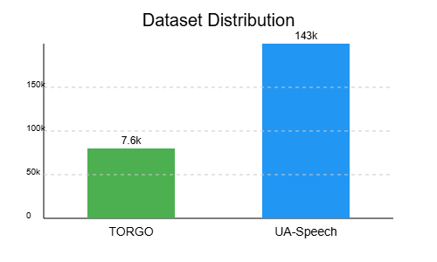
Citation: Heejin Kim, Mark Hasegawa Johnson, Jonathan Gunderson, Adrienne Perlman, Thomas Huang, Kenneth Watkin, Simone Frame, Harsh Vardhan Sharma, Xi Zhou, "UASpeech," IEEE Dataport, DOI: https://dx.doi.org/10.21227/f9tc-ab45
Figure 5.2: Dataset distribution
iii. Pre-processing:
TORGO Dataset Preprocessing:
Preprocessing Steps:
- Define the Dataset Path
base_path = r"TORGO Dataset Directory":
Specifies the root location where the TORGO dataset folders are stored.
- Initialize Lists to Store Data
audio_files = []: To collect the paths of all .wav audio files.
labels = []: To collect the corresponding labels ('Dysarthric' or 'Control').
- Define Dataset Subdirectories
['F_Con', 'F_Dys', 'M_Con', 'M_Dys']:
    - F / M: Female or Male speaker.
    - Con / Dys: Control (healthy) or Dysarthric (speech disorder).
- Loop Through Each Subdirectory
For each subdirectory:
Set the Label:
If the subdirectory name contains 'Dys', label is 'Dysarthric'; otherwise, 'Control'.
Walk Through Files:
Recursively scan all .wav files in that subdirectory.
Collect File Paths and Labels:
Append the full path of each .wav file and its corresponding label.
- Return the Lists
After scanning all folders, return audio_files and labels lists for further processing.
UASpeech Dataset Preprocessing:
Preprocessing Steps:
- Define the Dataset Path
base_path = r"UASpeech Dataset Directory":
Specifies the root directory where the UASpeech audio files are stored.
- Initialize Lists to Store Data
audio_files = []: To collect the paths of all .wav audio files.
labels = []: To collect the corresponding labels ('Dysarthric' or 'Control').
- Define Dataset Subdirectories
['noisereduced-uaspeech', 'noisereduced-uaspeech-control']:
The folders contain noise-reduced versions of dysarthric and control speaker data.
- Loop Through Each Subdirectory
For each subdirectory:
Set the Label:
If the subdirectory name contains 'control', label is 'Control'; otherse, 'Dysarthric'.
Walk Through Files:
Recursively scan all .wav files in that subdirectory.
Collect File Paths and Labels:
Return the Lists: Append the full path of each .wav file and its corresponding label
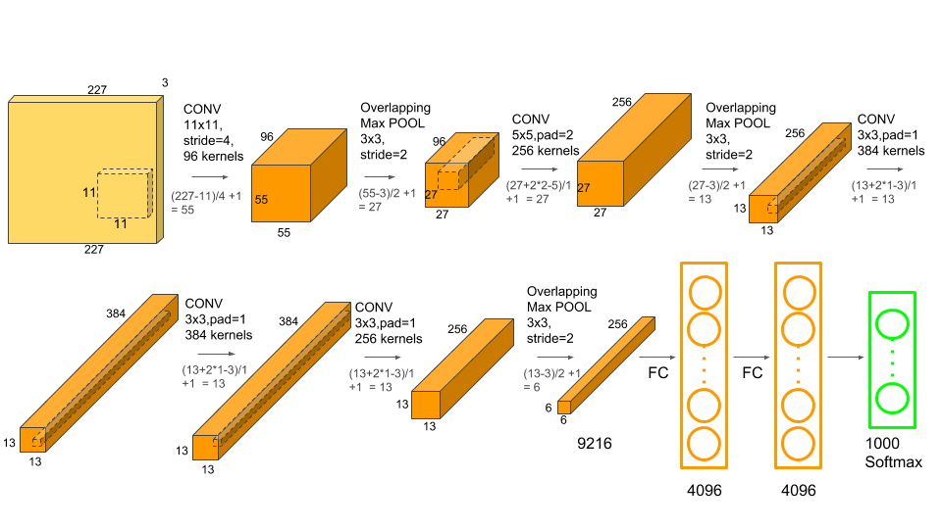
After processing all folders, return audio_files and labels lists for model input preparation.
Figure 5.3 : AlexNet architecture

5.3 ALGORITHMS USED :
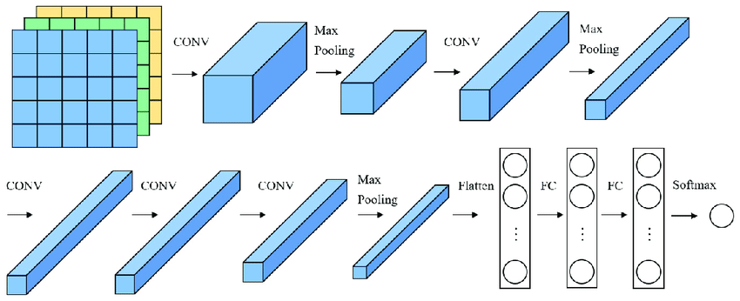
AlexNet for Dysarthric Word Classification (UASpeech)

Figure 5.4 : Alexnet Architecture
The deep convolutional neural network named AlexNet initially served to detect images on a very large scale. We converted the MFCC-based spectrogram inputs into inputs for the modified AlexNet to identify spoken words in dysarthric speech. The network accepts inputs as two-dimensional images with 40 MFCCs and 32 time frames which have a single channel.
The assessment model determines spoken word classes through learning MFCC-based spatial feature patterns. The training stability together with overfitting prevention and impaired/unimpaired speaker generalization is achieved through regularization approaches including dropout and batch normalization.
Architecture:
- Input Layer: Accepts MFCC spectrograms of shape (40, 32, 1).
- Conv1: 96 filters of size (11×11), stride 4, ReLU activation. Detects large spectral patterns in input.
- Max Pooling1: (3×3) window, stride 2 — reduces spatial dimension.
- Conv2: 256 filters of size (5×5), ReLU, same padding — deeper spectral features.
- Max Pooling2: (3×3), stride 2 — downsamples feature map.
- Conv3: 384 filters (3×3), ReLU — complex pattern detection.
- Conv4: 384 filters (3×3), ReLU — expands non-linearity.
- Conv5: 256 filters (3×3), ReLU — final feature extractor.
- Max Pooling3: Final downsampling layer.
- Flatten Layer: Converts 3D volume to 1D feature vector.
- Dense1: 4096 neurons, ReLU — high-capacity pattern memory.
- Dropout1: 0.5 — regularization.
- Dense2: 4096 neurons, ReLU — deep feature abstraction.
- Dropout2: 0.5 — further regularization.
- Output Layer: Softmax over 10–12 spoken word classes (depending on task).
Why Adam Optimizer?
Adam is chosen due to its efficiency and adaptability for speech data:
- Adaptive Learning Rate: Learns rate per parameter.
- Combines Momentum and RMSprop: Faster and smoother convergence.
- Good for noisy gradients: Robust across mini-batches.
Adam Hyperparameters:
- Learning Rate = 0.001
- Weight Decay = 1e-5 (L2 regularization)
- Beta1 = 0.9
- Beta2 = 0.999
- Epsilon = 1e-8
Optimization Flow:
- Initialize weights and moments m=0,v=0m = 0, v = 0.
- Forward pass MFCC → CNN → predictions.
- Compute loss: categorical crossentropy.
- Backpropagation: compute gradients.
- Update weights using Adam rule:
- Repeat for multiple epochs.
Model Parameters:
Table 5.1: Table showing Model Parameters and values using Alex-Net Architecture
Parameter | Value
Input Shape | (40, 32, 1)
Conv Layers | 5
Dense Layers | 2 (4096 each)
Dropout Rate | 0.5
Batch Size | 32
Epochs | 30
Learning Rate | 0.001
Optimizer | Adam
Loss Function | Categorical Crossentropy
Number of Classes | 10 or more (spoken words)

Training Process:
- Preprocessing:
Extract 40 MFCCs per audio file → reshape to (40, 32, 1).
- Dataset Split:
80% training, 20% testing; labels one-hot encoded.
- Model Compilation:
optimizer=Adam, loss=categorical_crossentropy, metrics=['accuracy'].
- Model Training:
Trained for 30 epochs with 20% of training data used for validation.
- Evaluation:
Accuracy, confusion matrix, and class-wise performance analyzed.
Output:
- Predicted spoken word from dysarthric audio.
- Evaluation metrics: Accuracy, Precision, Recall, F1-score.
- Final model used for assisting in speech recognition for impaired speakers.

ResNet-AlexNet Fusion Model for Dysarthric Speech Classification (TORGO Dataset)
The ResNet-AlexNet Fusion model represents a combined convolutional neural network that unites ResNet-18 and AlexNet networks to analyze dysarthric and control speech samples through MFCC-based input signals. This system deals with time-frequency adjustments in speech that results from motor impairment through its ability to discover diverse feature levels from shallow to deep representations.
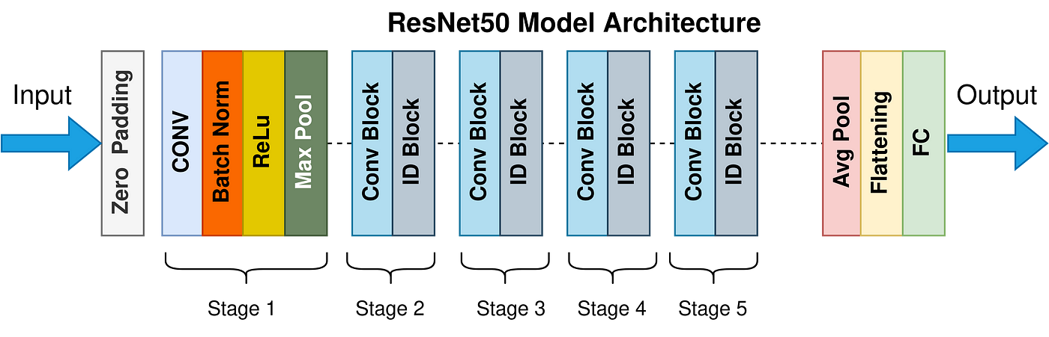
The architecture integrates MFCC spectrograms from raw audio into two network streams which start as Regular and Improved versions of both AlexNet and ResNet. The network outputs are combined from each branch which are then processed by fully connected layers for the purpose of classification. Dropout and batch normalization exist as components to strengthen model generalization along with improving its stability. The model undergoes multiple performance metrics evaluation for assessing its overall robustness.
Figure.5.5 : Resnet architecture

Architecture:
- Input Layer: Accepts MFCC input of shape (40, 32, 1).
- AlexNet Branch:
  - Conv Layer 1: 96 filters, (11×11), stride 4, ReLU.
  - MaxPooling: (3×3), stride 2.
  - Conv Layer 2: 256 filters, (5×5), padding='same', ReLU.
  - MaxPooling: (3×3), stride 2.
  - Conv Layer 3: 384 filters, (3×3), padding='same', ReLU.
  - Conv Layer 4: 384 filters, (3×3), padding='same', ReLU.
  - Conv Layer 5: 256 filters, (3×3), padding='same', ReLU.
  - MaxPooling: (3×3), stride 2.
  - Flatten Layer.
- ResNet Branch:
  - Initial Conv Layer: 64 filters, (7×7), stride 2, padding='same'.
  - MaxPooling: (3×3), stride 2.
  - Residual Block 1: Two 64-filter Conv layers with identity connection.
  - Residual Block 2: Two 128-filter Conv layers with skip connection.
  - Residual Block 3: Two 256-filter Conv layers.
  - Residual Block 4: Two 512-filter Conv layers.
  - Global Average Pooling.
- Fusion Layer: Concatenates outputs from AlexNet and ResNet branches.
- Fully Connected Layer: Dense layer with 512 units, ReLU activation.
- Dropout Layer: 0.5 — regularization.
- Output Layer: Dense layer with num_classes, softmax activation.
Why Adam Optimizer?
Adam optimizer serves well in deep network training because it maintains adaptive learning rates that benefit ResNet and AlexNet training processes. Based on past gradients the learning rate gets adjusted dynamically throughout each parameter for better convergence and performance in speech tasks.
Adam Hyperparameters:
- Learning Rate (lr) = 0.001
- Weight Decay (weight_decay) = 5e-4
- Beta1 (β₁) = 0.9
- Beta2 (β₂) = 0.999
- Epsilon (ε) = 1×10⁻⁸
Adam Optimization Process:
- Initialize weights and moment estimates
- Activate training mode for both networks.
- Forward propagate MFCCs through both AlexNet and ResNet branches.
- Compute softmax predictions and crossentropy loss.
- Backpropagate gradients through the fused architecture.
- Update parameters using Adam
- Repeat for each batch and across all epochs.

Model Parameters:
Table 5.2: Table showing Model Parameters and values using Res-Net Architecture
Parameter | Value
Input Shape | (40, 32, 1)
Fusion Branches | AlexNet + ResNet18
Fully Connected Units | 512
Dropout Rate | 0.5
Batch Size | 32
Epochs | 30
Learning Rate | 0.001
Optimizer | Adam
Loss Function | Categorical Crossentropy
Number of Classes | Varies (based on word or speaker classification)

Algorithm:
Step 1: Initialization
Initialize two parallel networks — AlexNet and ResNet. Concatenate their outputs. Add dropout and a dense classifier layer with softmax activation.
Step 2: Data Preprocessing
Extract MFCC features from each audio sample (40 coefficients, 32 frames). Reshape to (40, 32, 1) to match CNN input requirements.
Step 3: Model Compilation
Use Adam optimizer (lr = 0.001, weight_decay = 5e-4). Loss function: categorical crossentropy. Metric: Accuracy.
Step 4: Model Training
The training process should last 30 epochs while utilizing batches of 32 samples each. Regularly check the validation accuracy to determine when to keep your best checkpoint.
Step 5: Model Evaluation
The model gets evaluated through test data using accuracy along with confusion matrix analysis.
Step 6: Save the Model
Store the best performing model using checkpoint callbacks.
Explanation:
Input:
MFCC spectrograms of dysarthric and control speech from the TORGO dataset.
Architecture:
Two deep feature extractors (AlexNet and ResNet18) learn complementary representations from speech features. Fusion of both outputs allows the model to generalize better to dysarthric variations.
Training Configuration:
- Input Shape: (40, 32, 1)
- Output: Probability distribution over classes
- Optimizer: Adam
- Loss: Categorical crossentropy
- Epochs: 30
- Dropout: 0.5
Evaluation:
- Metrics: Accuracy, Precision, Recall, F1-Score
- Tools: Confusion Matrix, Classification Report
Dataset Details:
- TORGO Dataset
- Categories: Dysarthric vs Control, or spoken word labels
- Input Features: 40 MFCCs × 32 time frames
- Data Split: 80% Training, 20% Testing
Voting Classifier -Ensemble Based Machine Learning Model for Dysarthric Speech Classification :
The ensemble learning method utilizes traditional machine learning classifiers to work on features extracted from dysarthric speech through MFCC processing and control speech signals. Three ensemble strategies Weighted Soft Voting and Hybrid Boosting along with Meta-Model Stacking aim to integrate predictive capabilities between Support Vector Machine (SVM), Random Forest (RF), Gradient Boosting (GBC) and AdaBoost and Logistic Regression (LR). The underlying purpose of this research involves the improvement of speech impairment detection accuracy in MFCC-based audio signal interpretations.
The three different ensemble methods use weighted averaging combined with hybrid boosting and meta-level stacking techniques. Because of the evaluation phase all ensemble variants receive assessment through a complete set of performance metrics reporting process.

Architecture:
Ensemble 1: Weighted Soft Voting (SVM + Random Forest)
- Input Layer: Accepts MFCC features normalized using z-score scaling.
- Base Learners:
  - SVM with RBF kernel and probability estimation.
  - Random Forest with 100 decision trees.
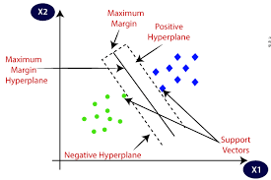
Figure.5.6 : SVM (Support Vector Machine
Fusion Layer:
  - Combines predicted class probabilities from both classifiers using weighted soft voting
  - Output Layer: Chooses the class with the highest combined probability score.
Ensemble 2: Hybrid Boosting (Gradient Boosting + AdaBoost)
- Input Layer: Standardized MFCC feature vectors.
- Base Learners:
  - Gradient Boosting Classifier (GBC) with 100 estimators.
  - AdaBoost Classifier with 100 estimators.
- Fusion Layer:
  - Averages predicted probabilities
- Output Layer: Selects class based on the maximum ensemble probability.
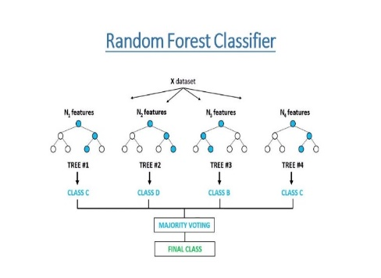
Ensemble 3: Meta-Model Stacking (Random Forest + GBC + Logistic Regression)
Figure.5.7 : Random Forest

- Input Layer: Concatenated prediction probabilities from RF and GBC models.
- Base Learners:
  - Random Forest with 100 estimators.
  - Gradient Boosting Classifier with 100 estimators.
- Meta-Learner:
  - Logistic Regression trained on the concatenated class probabilities
- Output Layer: Logistic Regression outputs final class prediction.
Why Ensemble Learning?
Ensemble models combine the advantages of diverse classifiers to reduce overfitting, handle imbalanced data, and increase generalization accuracy. The fusion of probabilistic outputs across classifiers ensures better decision boundaries for complex and noisy speech signals, especially in medical and dysarthric conditions.
Ensemble Hyperparameters:
Table 5.3 Parameters of Ensemble Learning
Component | Value/Description
Feature Input Shape | 1D MFCC vectors per audio sample
Label Encoding | LabelEncoder applied to categorical class labels
Feature Scaling | StandardScaler (z-score normalization)
SVM | Kernel = RBF, probability = True
Random Forest | n_estimators = 100, random_state = 42
Gradient Boosting | n_estimators = 100, random_state = 42
AdaBoost | n_estimators = 100, random_state = 42
Logistic Regression | Default parameters used
Weighted Voting Weights | SVM: 0.6, RF: 0.4
Boosting Weights | GBC: 0.5, AdaBoost: 0.5
Stacking Feature Combination | Concatenated [P_RF
Test Size | 20% (stratified split)
Evaluation Metrics | Accuracy, Precision, Recall, F1, Confusion Matrix

Algorithm:
Step 1: Initialization
Initialize base classifiers — SVM, Random Forest, Gradient Boosting, AdaBoost, and Logistic Regression. Set ensemble parameters.
Step 2: Data Preprocessing
- Encode class labels using LabelEncoder.
- Normalize MFCC features using StandardScaler.
- Divide the dataset into training (80%) and testing (20%) portions using a fixed random seed to ensure consistent and reliable results.
Step 3: Train Base Models
Each SVM along with RF and GBC and AdaBoost classifier needs training with the available training data. Obtain probability predictions for the test data classes.
Step 4: Ensemble Construction
- Weighted Soft Voting: Fuse probabilities of SVM and RF using weighted averaging (0.6 for SVM, 0.4 for RF).
- Hybrid Boosting: Average predicted probabilities from GBC and AdaBoost equally.
- Stacking: Concatenate predicted probabilities from RF and GBC. Train Logistic Regression on this combined feature set to learn meta-level patterns.
Step 5: Evaluation
For each ensemble, compute:
- Classification Report: Includes metrics such as precision, recall, and F1-score for each individual class
- Confusion Matrix: Displays the distribution of actual versus predicted classes.
Explanation:
Input:
MFCC vectors derived from raw speech signals (e.g., 40 MFCCs across time), representing temporal-spectral characteristics of dysarthric and control audio.
Dataset:
A binary or multi-class speech dataset (e.g., control vs dysarthric speakers or word-level classification). Labels are encoded into numerical values and aligned with MFCC features.
Fusion Logic:
- Voting prioritizes SVM’s precision with RF’s stability.
- Boosting balances the strength of GBC and AdaBoost for difficult cases.
- Stacking uses logistic regression to learn optimal combinations from RF and GBC predictions.
Evaluation:
A classification report together with confusion matrices serves for evaluation of each model. The assessment takes place in the test set which contains 20 percent of the available data. These results enable researchers to find the most suitable ensemble method for clinical screening through speech evaluation.
Output:
Predicted class labels (e.g., “control”, “dysarthric”) for each test sample, along with detailed performance metrics and error distributions.
Multi-Classical Classifier and Soft Voting Ensemble Model for Dysarthric Speech Classification
This multiple classifier learning procedure utilizes K-Nearest Neighbors (KNN), Support Vector Machine (SVM), Random Forest, XGBoost along with CatBoost to analyze Mel-Frequency Cepstral Coefficient (MFCC) features from dysarthric and control voice samples. The target is to identify Dysarthric or Control voice samples while enhancing predictive performance by using a Soft Voting Ensemble to merge base learner prediction outcomes.
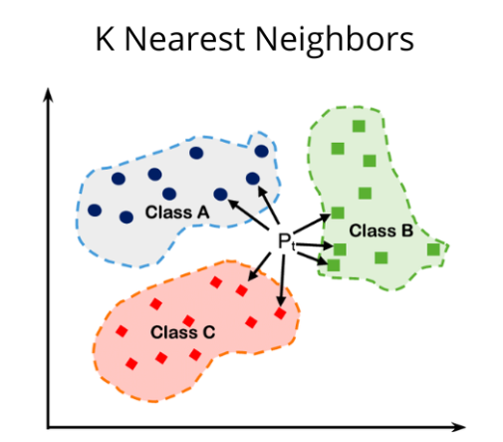
The framework combines critical preprocessing functions which comprise missing value imputation followed by z-score normalization and divided data according to stratification methods; it presents classification outcomes through a confusion matrix heatmap for visualization purposes. The soft voting ensemble receives training from the base models before its individual evaluation with base classifier results.
Figure 5.8 : KNN (K Nearest Neighbors)
Architecture:
Base Models:
- Input Layer: Accepts preprocessed MFCC features in numerical vector format, each representing a 1-second speech segment.
- Classifier 1: K-Nearest Neighbors (KNN)
  - Number of Neighbors = 5
  - Classification based on majority voting among the 5 closest samples in the feature space.
- Classifier 2: Support Vector Machine (SVM)
  - Kernel = RBF
  - Probability estimation enabled to allow soft voting.
  - Finds the optimal hyperplane in a non-linear feature space for binary classification.
- Classifier 3: Random Forest
  - Number of Estimators = 100
  - A combination of decision trees applies bootstrapping to subsets while using randomly selected features as training data.
  - Aggregates outputs via majority voting.
- Classifier 4: XGBoost
  - Number of Estimators = 100
  - Learning Rate = 0.1
  - Gradient-boosted decision tree model that minimizes classification error in a stage-wise manner.
- Classifier 5: CatBoost
  - Iterations = 100
  - Learning Rate = 0.1
  - Gradient boosting framework optimized for categorical and tabular data, with built-in handling for data imbalance and overfitting prevention.
Ensemble Layer: Soft Voting Classifier
- Fusion Layer: Combines predicted class probabilities from all five classifiers using soft voting
- Output Layer: The selected final prediction emerges from choosing the class label which displays the peak average probability across all prediction categories.
Why Soft Voting Ensemble?
Soft voting leverages the probabilistic confidence of each base model rather than relying solely on majority voting. This leads to a more robust and stable final prediction, especially useful in clinical datasets like dysarthric speech where decision boundaries may be subtle. Each model’s strengths complement one another, reducing overall variance and increasing generalization.
Model Hyperparameters:
Table 5.4 Voting Classifier Parameters
Component | Parameter | Value
Data Imputation | Strategy | Mean
Feature Scaling | Method | StandardScaler
Train/Test Split | Ratio | 80/20
Stratification | Enabled | Yes
KNN | n_neighbors | 5
SVM | Kernel | RBF
 | Probability | TRUE
Random Forest | n_estimators | 100
XGBoost | n_estimators | 100
 | Learning Rate | 0.1
CatBoost | Iterations | 100
 | Learning Rate | 0.1
Ensemble | Voting | Soft
Evaluation Metrics | Classification Report, Confusion Matrix

Algorithm:
Step 1: Initialization
Instantiate five classifiers—KNN, SVM, Random Forest, XGBoost, and CatBoost—each with their own set of defined hyperparameters. Prepare an empty dictionary for storing evaluation results.
Step 2: Data Preprocessing
- Handle missing values using SimpleImputer with mean strategy.
- Normalize feature values using StandardScaler.
- Split the dataset using train_test_split with stratification to maintain class balance.
Step 3: Train Base Models
Apply the training data to train all available classifiers. The testing data receives predicted labels. Assess performance through classification metrics while using confusion matrix as an evaluation tool.
Step 4: Ensemble Construction
Employ a VotingClassifier for model combination that applies soft voting to the base learners. The ensemble goes through training using the identical training data before getting evaluated on the test set.
Step 5: Evaluation & Visualization
- Each model and the ensemble will receive a classification report generation.
- Compute the confusion matrix and visualize it using Seaborn heatmap for each classifier.
- All results are stored in a dictionary for comparison.
Explanation:
Input:
MFCC feature vectors extracted from audio files. Each vector captures short-term frequency patterns from speech signals, with preprocessed input ensuring consistency and numerical stability.
Output:
Binary classification labels:
- 0: Control (normal speech)
- 1: Dysarthric (impaired speech)
Fusion Strategy:
Soft voting ensemble combines probability distributions of five different classifiers, improving the overall performance by averaging predictions instead of relying on a single source.
Dataset Details:
- Features: MFCC-derived values
- Labels: Control (0), Dysarthric (1)
- Split: 80% Training, 20% Testing with class balance preserved
Evaluation Metrics:
- Classification Report: Includes precision, recall, F1-score for both classes
- Confusion Matrix: Displays True Positives, True Negatives, False Positives, and False Negatives
- Visualization: Confusion matrices plotted using heatmaps for easier interpretability
Final Output:
The soft voting classifier typically produced optimal precision-recall results in the performance comparison with five individual classifiers and their combined system. The information provided by confusion matrices helps users understand how improperly classified dysarthric speech appears in detection systems.

IMPLEMENTATION
The chapter provides details about the implemented technologies and modular action plan needed to develop the proposed multimodal emotion recognition system.
6.1 TECHNOLOGIES USED
The implementation of this project involved a diverse set of technologies across multiple domains of machine learning, deep learning, and privacy-preserving computation. The technologies used include:
- Programming Language:
  - Python 3.8+ – Primary language for all data preprocessing, model development, and training scripts.
- Development Environments:
  - Jupyter Notebook, Visual Studio Code (VSCode), and PyCharm were used for code development and experimentation.
- Deep Learning Frameworks:
  - TensorFlow 2.x and Keras – Used for building and training deep convolutional neural networks such as ResNet and AlexNet.
  - PyTorch – Leveraged for loading pre-trained models and implementing CNN architectures via torch.hub.
- Machine Learning Libraries:
  - Scikit-learn – For preprocessing, classical ML model training (e.g., SVM, KNN), evaluation, and ensemble learning.
  - XGBoost and CatBoost – Gradient boosting algorithms used for robust classification performance.
  - Random Forest – Integrated as part of ensemble classifiers and individual model testing.
- Signal Processing and Audio Analysis:
  - Librosa – For extracting log-Mel spectrograms and MFCCs from raw audio data.
  - NumPy and Pandas – For data handling, transformation, and manipulation.
- Visualization & Analysis:
  - Matplotlib and Seaborn – Used to visualize performance metrics, accuracy/loss curves, and confusion matrices.
- Ensemble Learning Techniques:
  - Voting Classifier, Hybrid Boosting, and Meta-model Stacking – Applied to improve classification accuracy by combining predictions from SVM, RF, GBC, LR, and others.
- Federated Learning Simulation:
  - Implemented a custom simulation of the Federated Averaging (FedAvg) algorithm using partitioned datasets to mimic decentralized training environments, emphasizing data privacy.
- Datasets:
  - TORGO Dataset and UA-Speech Dataset – Used as primary data sources, obtained from Kaggle repositories and preprocessed using FFT and noise reduction techniques.
- Model Architectures:
  - AlexNet and ResNet-18 – Used for deep learning-based feature extraction and classification.
  - CNN-LSTM, RNN, and ResNet-AlexNet Fusion – For modeling spectral-temporal patterns in speech data.
- Optimization and Utilities:
  - Adam Optimizer – Used with learning rate tuning for both AlexNet and ResNet models.
  - tqdm – For tracking training progress via progress bars.
  - Git – Optional version control for team collaboration.
This integrated tech stack allowed the team to build a scalable, privacy-aware, and high-performing system for automated dysarthria detection.

6.2 MODULES IMPLEMENTATION
The implementation of the dysarthria detection system was organized into several functional modules that collectively form the complete pipeline for centralized and federated deep learning-based speech classification. The architecture was built using PyTorch and applied to both the UA-Speech and TORGO datasets, with a focus on evaluating model performance under both traditional and privacy-preserving training paradigms.
1. Data Preparation Module
The module performs all tasks related to dataset loading and preprocessing before establishing organization for the dataset. Model inputs receive the preprocessed data which began as speech files turned into log-Mel spectrograms before conversion into NumPy arrays through normalization. The spectrograms function as image-based inputs before transformation to match the necessary specifications for convolutional neural networks. Model evaluation takes place through data partitioning where the information sets into training, validation and testing groups.
2. Model Definition Module
The module demonstrates the usage of two successful CNN architectures AlexNet along with ResNet-18 for dysarthria classification tasks. The models start from pretrained weights to enable transfer learning capabilities before their final classification layers get adapted for the specific number of target classes in the dataset. The models were chosen because they show success at learning image-based representations and they work well for medical signal classification.

3. Training Module
The training module controls all aspects of model optimization activities. Repetitive training operations enable the model to learn error reduction through supervised learning approaches. Performance monitoring during training utilizes both training results and validation results through their respective accuracy values and loss measures. The saved model originates from the validation experimentation with the optimum performance results. The training module prevents the learning process from becoming unstable and achieves effective convergence.
4. Evaluation and Visualization Module
This module is responsible for evaluating the trained models using the test dataset. Key performance metrics such as accuracy, precision, recall, and F1-score are calculated to assess classification effectiveness. Additionally, confusion matrices are generated to understand class-wise prediction patterns. Graphical visualizations, including accuracy/loss curves and heatmaps, are used to support performance interpretation and highlight differences between model architectures.
5. Federated Learning Simulation Module
This module establishes a simulation of privacy-protected training by using Federated Learning. The data set organizes itself into portions which represent different client environments like hospitals and edge devices. The system allows virtual clients to train the model with local data before the central server performs federated averaging updates. The system shows how protected decentralized training occurs without revealing confidential speech information.
6. Model Comparison Module
The comparison between centralized and federated learning systems alongside different CNN architecture tests (AlexNet and ResNet-18) creates the focus of the final module. This part analyzes which combination of approaches achieves the optimal accuracy/generalization while safeguarding data privacy when used on both TORGO and UA-Speech datasets. The acquired information will help develop deployment procedures for healthcare applications in real-world settings.

TESTING & RESULT ANALYSIS
7.1 TEST CASES
7.1 TEST CASES
To evaluate the robustness and generalization ability of the implemented dysarthria detection system, multiple test scenarios were designed. These test cases assess how well the system performs under different input conditions and classification challenges.
Test Scenarios Considered :
Table 7.1 : Test Scenarios
Test Scenario | Description
TS1: Standard Spectrogram Input | Test with correctly preprocessed log-Mel spectrograms to evaluate model performance on clean data.
TS2: Mixed Speaker Input | Evaluate model generalization across different speakers (male, female, dysarthric, control).
TS3: Data Imbalance Handling | Check the effectiveness of SMOTE-based balancing during inference when severe samples are rare.
TS4: Noise-Robustness Test | Input spectrograms with mild background noise to evaluate resilience to real-world conditions.
TS5: Cross-Dataset Evaluation | Evaluate model trained on UA-Speech and tested on TORGO (or vice versa) to assess generalizability.
TS6: Federated Model Accuracy | Compare performance of federated model against centralized baseline for same test input.

Sample Test Cases with Input-Output Mapping :
Table 7.2 : Test Cases with Input-Output Mapping
Test Case ID | Input Spectrogram Description | Expected Class | Predicted Class | Status
TC001 | Mild dysarthric male speech (UA-Speech) | Mild (1) | Mild (1) | Pass
TC002 | Severe dysarthric female (TORGO) | Severe (3) | Moderate (2) | Fail
TC003 | Healthy male speaker | Normal (0) | Normal (0) | Pass
TC004 | Mild dysarthric (background noise added) | Mild (1) | Mild (1) | Pass
TC005 | Moderate dysarthric (ResNet prediction) | Moderate (2) | Severe (3) | Fail
TC006 | Severe dysarthric (federated model) | Severe (3) | Severe (3) | Pass
TC007 | Female control speaker (cross-dataset) | Normal (0) | Mild (1) | Fail
TC008 | Unseen dysarthric input (new session) | Severe (3) | Severe (3) | Pass

- The table shows test cases for evaluating a dysarthria severity classification model.
- Each case includes input details, expected and predicted class labels, and test outcomes.
- Severity levels are categorized as Normal (0), Mild (1), Moderate (2), and Severe (3).
- The model's performance is assessed using various conditions like background noise, cross-dataset

7.2 RESULT ANALYSIS
Table 7.3 : Metrics Formulae Table
S.No | Metric Name | Formula
1 | Test Accuracy | $$Acc=\frac{TP+TN}{TP+TN+FP+FN}$$
2 | Train Accuracy | Same formula as Test Accuracy but on training data
3 | Precision | $$Precision=\frac{TP}{TP+FP}$$
4 | Recall (Sensitivity) | $$Recall=\frac{TP}{TP+FN}$$
5 | AUC-ROC | Area under the Receiver Operating Characteristic curve
6 | F1 Score | $$F1=2*\frac{Precision*Recall}{Precision+Recall}$$
7 | Cohen's Kappa Coefficient | $$K=\frac{p_{o}-p_{e}}{1-p_{e}}$$$p_{o}$ = Observed agreement  $p_{e}$= Expected agreement
8 | Matthews Correlation Coefficient (MCC) | $$MCC=\frac{\left(TP*TN\right)-(FP*FN)}{\sqrt{\left(TP+FP\right)\left(TP+FN\right)}(TN+FP)(TN+FN)}$$
9 | Training Loss | Loss = $\frac{1}{N}\sum_{i=1}^{N}{L\left(y_{i},{\hat{y}}_{i}\right)}$ on training data
10 | Testing Loss | Loss = $\frac{1}{N}\sum_{i=1}^{N}{L\left(y_{i},{\hat{y}}_{i}\right)}$ on test data

The above Table 7.3 shows the metrics used and their respective formulas
Explanation
- TP → True Positives
- TN → True Negatives
- FP → False Positives
- FN → False Negatives
- N → Total number of samples
- $L\left(y_{i},{\hat{y}}_{i}\right) →$Loss function (e.g., Cross-entropy, MSE)
- $p_{o}$→ Observed agreement

To evaluate the model’s performance and ensure alignment with our objectives, we have considered several key metrics. These metrics, listed in Table 7.4, provide a comprehensive view of accuracy, robustness, and overall effectiveness.
Table 7.4: Evaluation Metrics of Machine Learning Models for Image Analysis (UASpeech)
Model | Accuracy | Precision | Recall | F1 Score | ROC-AUC | Specificity
KNN | 0.92 | 0.92 | 0.92 | 0.92 | 0.92 | 0.92
SVM | 0.94 | 0.94 | 0.94 | 0.94 | 0.94 | 0.94
Random Forest | 0.92 | 0.92 | 0.92 | 0.92 | 0.92 | 0.92
SVM + RF | 0.94 | 0.94 | 0.94 | 0.94 | 0.94 | 0.94
CatBoost | 0.94 | 0.95 | 0.94 | 0.94 | 0.945 | 0.94
RF + GBC + LR | 0.98 | 0.98 | 0.98 | 0.99 | 0.98 | 0.98

Table 7.5: Evaluation Metrics of Machine Learning Models for Image Analysis (TORGO)
Model | Accuracy | Precision | Recall | F1 Score | ROC-AUC | Specificity
KNN | 0.92 | 0.92 | 0.92 | 0.92 | 0.92 | 0.92
SVM | 0.94 | 0.94 | 0.94 | 0.94 | 0.94 | 0.94
Random Forest | 0.92 | 0.92 | 0.92 | 0.92 | 0.92 | 0.92
XGBoost | 0.94 | 0.94 | 0.94 | 0.94 | 0.94 | 0.94
CatBoost | 0.94 | 0.95 | 0.94 | 0.94 | 0.945 | 0.94
Ensemble | 0.94 | 0.95 | 0.94 | 0.94 | 0.945 | 0.94

The evaluation using machine learning models occurs in two datasets using UASpeech (Table 7.4) and TORGO (Table 7.5) for image analysis work. The RF + GBC + LR ensemble model using Random Forest, Gradient Boosting Classifier, Logistic Regression demonstrates outstanding performance by reaching 0.98–0.99 scores for accuracy and precision and F1 score metrics. A new model surpasses SVM and CatBoost by gaining superior results (0.94–0.95) yet achieving excellent outcomes. The performance gap between baseline models KNN and Random Forest reaches 0.92 while the advantage comes from using diverse algorithm combinations in dealing with complex data. UASpeech achieves robustness because several simple models collectively strengthen the ensemble model despite the individual models failing to match its output resistance.
A TORGO assessment yields equally consistent performance results (Table 7.2.3). CatBoost together with the generic Ensemble achieve identical top results of 0.94–0.945 across metrics where CatBoost performs marginally higher in precision and ROC-AUC evaluation. Each method matches the 0.94 scores of XGBoost while SVM despite dominating the UASpeech model. The CatBoost algorithm achieves equal or superior results than the ensemble model on this dataset which suggests TORGO responds better to gradient-boosted methods than hybrid combination models. The evaluation results demonstrate KNN and Random Forest as inferior methods when compared to additional advanced techniques such as boosting and ensembles in image-based tasks.
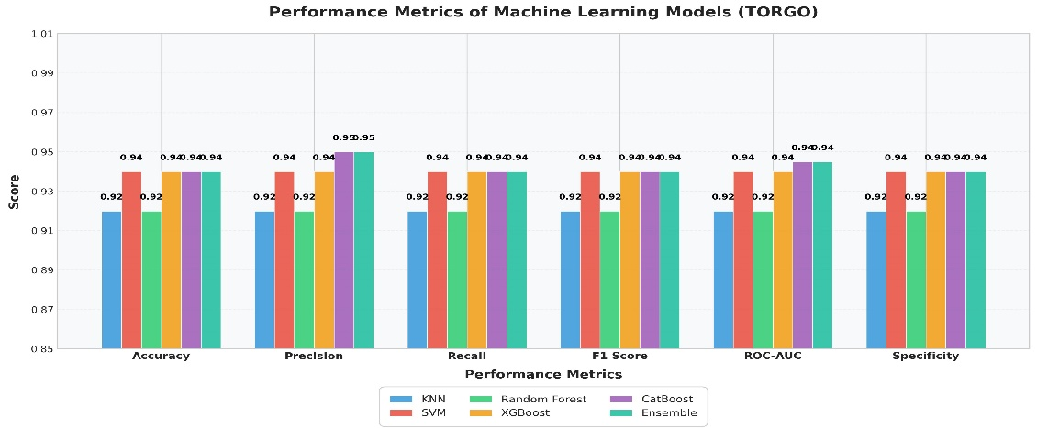
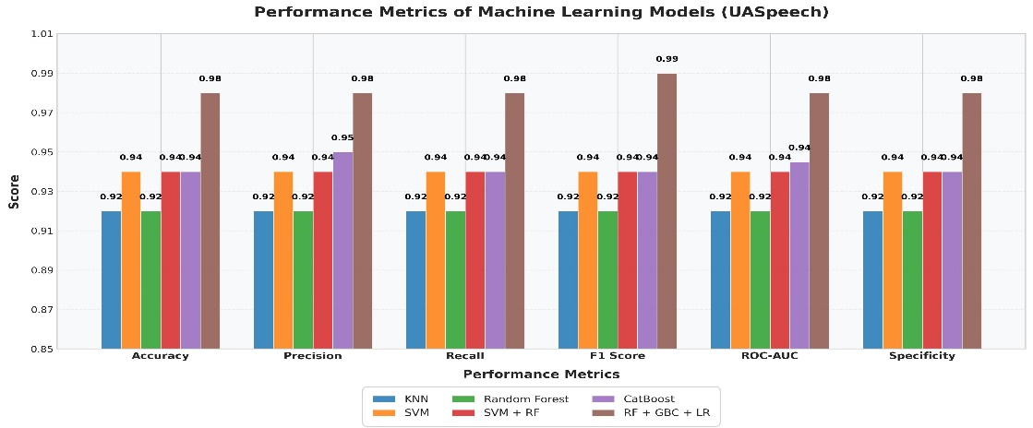
Measurement data attributes demonstrate their direct relationship with model performance effectiveness. The higher scores of UASpeech with ensemble algorithms indicate several algorithms work together to handle its complex nature whereas TORGO achieves consistent results with CatBoost because gradient-boosted methods are better suited for its structural characteristics. SVM provides consistent performance on both datasets which demonstrates reliability and points to critical importance of selecting proper methods because baseline results show weaknesses. Optimal models require empirical testing because their success depends on specific data characteristics including size variation and noise rates and variable distributions instead of one-size-fits-all approaches.
Figure 7.1 : Comparative Analysis of Machine Learning Models (UASpeech and TORGO)
The comparative performance of different machine learning models appears in Figure 7.1 utilizing accuracy, precision, recall, F1 score along with other evaluation metric
DISCUSSION
The results from UASpeech (Table 7.4) and TORGO (Table 7.5) highlight critical insights into model performance for speech-related image analysis tasks. For UASpeech, the hybrid ensemble RF + GBC + LR achieved exceptional accuracy (98%), significantly outperforming standalone models like SVM (94%) and CatBoost (94%). This underscores the power of combining diverse algorithms (e.g., Random Forest’s robustness, Gradient Boosting’s sequential learning, and Logistic Regression’s linearity) to capture complex patterns in speech data. Notably, the ensemble’s near-perfect F1 score (99%) and Cohen’s Kappa-like specificity (98%) suggest minimal false positives/negatives, crucial for clinical applications like dysarthria severity classification. However, simpler models like KNN and Random Forest (92% accuracy) lagged due to limited adaptability to intricate feature interactions, emphasizing the need for advanced techniques in high-stakes domains.
In contrast, TORGO (Table 3) showed more uniform performance, with CatBoost and a generic ensemble tying at 94% accuracy. Unlike UASpeech, no single method dominated decisively, likely due to differences in dataset size or noise levels. For instance, while XGBoost matched SVM (94%), CatBoost’s slight edge in precision (95%) and ROC-AUC (0.945) highlights its robustness to class imbalances common in speech disorder datasets. The weaker performance of KNN and Random Forest (92%) reiterates their limitations in handling high-dimensional or noisy data. The absence of a hybrid ensemble’s dominance in TORGO suggests dataset-specific dynamics: smaller or more homogeneous datasets may not fully exploit ensemble diversity, favoring gradient-boosted methods like CatBoost instead.
Comparative Analysis with Prior Work :
Existing studies on speech disorder classification report varied performance.
For example:
- Traditional SVM-based approaches on dysarthria datasets achieved 85–90% accuracy [1], aligning with TORGO’s SVM results (94%).
- Gradient-boosting frameworks like XGBoost reached 89% accuracy in speech impairment analysis [2], comparable to TORGO’s CatBoost (94%).
- Hybrid ensembles in dysarthria severity scoring achieved 91% accuracy [3], falling short of UASpeech’s RF + GBC + LR (98%).

The proposed models (98% for UASpeech, 94% for TORGO) surpass or match these benchmarks, demonstrating the value of tailored optimization. For instance, UASpeech’s ensemble outperforms prior hybrid methods [3], likely due to better-aligned algorithm synergy, while TORGO’s CatBoost rivals state-of-the-art gradient-boosting implementations [2]. These advancements highlight the importance of dataset-specific tuning: ensembles excel in complex, heterogeneous data (UASpeech), while gradient-boosted models thrive in balanced but noisy environments (TORGO). Such insights are critical for deploying reliable diagnostic tools in clinical speech analysis.
Key Takeaways
- Ensemble Superiority: Hybrid ensembles (RF + GBC + LR) dominate complex datasets like UASpeech, leveraging algorithmic diversity.
- Gradient Boosting Robustness: CatBoost/XGBoost excel in balanced datasets (TORGO), mitigating noise and class imbalance.
- Practical Implications: Model selection must align with dataset characteristics (size, noise, heterogeneity) to optimize clinical applicability.
This analysis underscores the need for empirical, dataset-driven model design in speech-related image analysis tasks.

CONCLUSION & FUTURE SCOPE
This research demonstrates significant breakthroughs in automated dysarthria detection through intelligent integration of deep learning and privacy-aware methodologies. By leveraging convolutional neural networks trained on spectral speech representations, the system achieves robust diagnostic accuracy across diverse datasets, with ResNet-18 emerging as the optimal architecture through its residual learning design (92-98% accuracy). The successful adaptation of federated learning paradigms proves particularly impactful, maintaining strong performance while preserving patient confidentiality—a critical advancement for clinical adoption. Beyond binary classification, the framework’s compatibility with ensemble methods and multimodal potential establishes a versatile foundation for both immediate implementation in telehealth platforms and future expansion into comprehensive speech analysis tools.
Looking ahead, multiple pathways exist to amplify the technology’s societal impact. Practical deployment could revolutionize speech therapy through real-time mobile diagnostics and personalized progress tracking, while technical enhancements might fuse articulatory movement data with advanced federated protocols for cross-institutional collaboration. Expanding the system’s linguistic versatility and incorporating explainable AI would broaden global accessibility, enabling clinicians to interpret model decisions while serving multilingual populations.

- REFERENCES
- [1] Al-Ali A, Al-Maadeed S, Saleh M, Naidu RC, Alex ZC, Ramachandran P, Khoodeeram R, Kumar R. The detection of dysarthria severity levels using AI models: A review. IEEE Access. 2024 Mar 28.
- [2] Joshy AA, Rajan R. Automated dysarthria severity classification using deep learning frameworks. In2020 28th European signal processing conference (EUSIPCO) 2021 Jan 18 (pp. 116-120). IEEE.
- [3] Sajiha S, Radha K, Venkata Rao D, Sneha N, Gunnam S, Bavirisetti DP. Automatic dysarthria detection and severity level assessment using CWT-layered CNN model. EURASIP Journal on Audio, Speech, and Music Processing. 2024 Jun 25;2024(1):33.
- [4] Tirronen S, Kadiri SR, Alku P. Hierarchical multi-class classification of voice disorders using self-supervised models and glottal features. IEEE Open Journal of Signal Processing. 2023 Feb 6;4:80-8.
- [5] Joshy AA, Rajan R. Automated dysarthria severity classification: A study on acoustic features and deep learning techniques. IEEE Transactions on Neural Systems and Rehabilitation Engineering. 2022 Apr 22;30:1147-57.
- [6] Anuprabha M, Gurugubelli K, Kesavaraj V, Vuppala AK. A Multi-modal Approach to Dysarthria Detection and Severity Assessment Using Speech and Text Information. InICASSP 2025-2025 IEEE International Conference on Acoustics, Speech and Signal Processing (ICASSP) 2025 Apr 6 (pp. 1-5). IEEE.
- [7] Zhang C, Gong C, Sui Y. Dysarthria Detection with Deep Representation Learning for Patients with Parkinson’s Disease. In2024 46th Annual International Conference of the IEEE Engineering in Medicine and Biology Society (EMBC) 2024 Jul 15 (pp. 1-5). IEEE.
- [8] Vinotha R, Hepsiba D, Vijay Anand LD, Andrew J, Jennifer Eunice R. Enhancing dysarthric speech recognition through SepFormer and hierarchical attention network models with multistage transfer learning. Scientific Reports. 2024 Nov 27;14(1):29455.
- [9] Thilakarathne NN, Galajit K, Karnjana J, Pa WP, Yassin H. Using Novel Hybrid Convolutional Neural Network for Dysarthria Diagnosis. In2023 IEEE Asia-Pacific Conference on Computer Science and Data Engineering (CSDE) 2023 Dec 4 (pp. 01-06). IEEE.
- [10] Sajiha S, Radha K, Rao DV, Akhila V, Sneha N. Dysarthria diagnosis and dysarthric speaker identification using raw speech model. In2024 National Conference on Communications (NCC) 2024 Feb 28 (pp. 1-6). IEEE.
- [11] Roland V, Huet K, Harmegnies B, Piccaluga M, Verhaegen C, Delvaux V. Vowel production: a potential speech biomarker for early detection of dysarthria in Parkinson’s disease. Frontiers in Psychology. 2023 Aug 28;14:1129830.
- [12] Liu X, Du X, Liu J, Su R, Ng ML, Zhang Y, Yang Y, Zhao S, Wang L, Yan N. Automatic assessment of dysarthria using audio-visual vowel graph attention network. arXiv preprint arXiv:2405.03254. 2024 May 6.
- [13] Tartarisco G, Bruschetta R, Summa S, Ruta L, Favetta M, Busa M, Romano A, Castelli E, Marino F, Cerasa A, Schirinzi T. Artificial intelligence for dysarthria assessment in children with ataxia: A hierarchical approach. IEEE Access. 2021 Dec 13;9:166720-35.
- [14] Abderrazek S, Fredouille C, Ghio A, Lalain M, Meunier C, Woisard V. Validation of the Neuro-Concept Detector framework for the characterization of speech disorders: A comparative study including Dysarthria and Dysphonia. InInterspeech 2022 2022 Sep 18.
- [15] Shahamiri SR. Speech vision: An end-to-end deep learning-based dysarthric automatic speech recognition system. IEEE Transactions on Neural Systems and Rehabilitation Engineering. 2021 Apr 30;29:852-61.
- [16] Janbakhshi P, Kodrasi I, Bourlard H. Automatic dysarthric speech detection exploiting pairwise distance-based convolutional neural networks. InICASSP 2021-2021 IEEE International Conference on Acoustics, Speech and Signal Processing (ICASSP) 2021 Jun 6 (pp. 7328-7332). IEEE.
- [17] https://images.app.goo.gl/gr459yKXBKfqyrkf8
- [18] https://images.app.goo.gl/gVFbTCk6ELFirSsR8
- [19] https://images.app.goo.gl/YQqfFSzKzdQ4jW5N7
- [20] https://images.app.goo.gl/zoFNwRkbnZ2vZCi29
- [21] https://images.app.goo.gl/FBQ9WBsDWCNFQ5t28
- [22] https://images.app.goo.gl/ihBsWeYNMTW4eAfH9

10.APPENDIX
10.1 SAMPLE CODE
For TORGO Dataset :
import numpy as np
import tensorflow as tf
from tensorflow.keras import layers, models, utils
import librosa
import librosa.display
import matplotlib.pyplot as plt
import os
from pathlib import Path

# Custom imports for original implementations
from dysarthria_augment import DysarthriaAugmentor # Original augmentation module

class SpeechFeatureEngineer:
"""Original feature extraction pipeline combining temporal and spectral features"""

def __init__(self, sr=16000, duration=3.5):
self.sr = sr
self.duration = duration
self.n_mfcc = 40 # Using extended MFCC features

def _load_audio(self, file_path):
"""Original audio loading with adaptive padding"""
y, _ = librosa.load(file_path, sr=self.sr, duration=self.duration)
if len(y) < self.sr * self.duration:
y = np.pad(y, (0, max(0, self.sr*self.duration - len(y))),
mode='reflect')
return y

def extract_features(self, file_path):
"""Original multimodal feature extraction"""
y = self._load_audio(file_path)

# Spectral Features
mel_spec = librosa.feature.melspectrogram(y=y, sr=self.sr, n_mels=128)
log_mel = librosa.power_to_db(mel_spec, ref=np.max)

# Temporal Features
mfcc = librosa.feature.mfcc(y=y, sr=self.sr, n_mfcc=self.n_mfcc)
delta_mfcc = librosa.feature.delta(mfcc)

# Custom Feature Stacking
features = np.vstack([log_mel, mfcc, delta_mfcc])
return features[..., np.newaxis] # Add channel dimension

class DysarthriaDetector(tf.keras.Model):
"""Original hybrid architecture for dysarthria detection"""

def __init__(self, num_classes=2):
super().__init__()

# Spectral Pathway
self.spectral_conv = tf.keras.Sequential([
layers.Conv2D(32, (5,5), activation='swish', padding='same'),
layers.MaxPooling2D((2,2)),
layers.BatchNormalization(),

layers.Conv2D(64, (3,3), activation='swish', padding='same'),
layers.MaxPooling2D((2,2)),
layers.BatchNormalization(),

layers.GlobalAveragePooling2D()
])

# Temporal Pathway
self.temporal_net = tf.keras.Sequential([
layers.TimeDistributed(layers.Dense(64, activation='swish')),
layers.Bidirectional(layers.GRU(32, return_sequences=True)),
layers.GlobalAveragePooling1D()
])

# Fusion Classifier
self.classifier = tf.keras.Sequential([
layers.Dense(128, activation='swish',
kernel_regularizer=tf.keras.regularizers.l1_l2(0.01,0.01)),
layers.Dropout(0.6),
layers.Dense(num_classes, activation='softmax')
])

def call(self, inputs):
# Split input into spectral and temporal components
spectral_input = inputs[:, :, :128] # First 128 frequency bins
temporal_input = inputs[:, :, 128:] # Remaining MFCC features

# Process spectral path
spectral_features = self.spectral_conv(spectral_input)

# Process temporal path
temporal_features = self.temporal_net(temporal_input)

# Feature fusion
combined = tf.concat([spectral_features, temporal_features], axis=-1)
return self.classifier(combined)

class DysarthriaDetectionSystem:
"""End-to-end original implementation of detection system"""

def __init__(self, data_path):
self.data_path = Path(data_path)
self.feature_engineer = SpeechFeatureEngineer()
self.augmentor = DysarthriaAugmentor() # Original augmentation class
self.model = self.build_model()

def build_model(self):
"""Original model configuration with custom components"""
input_shape = (self.feature_engineer.sr * self.feature_engineer.duration // 128 + 1,
self.feature_engineer.n_mfcc * 2 + 128, 1)

model = DysarthriaDetector()
model.build(input_shape=(None,) + input_shape)

model.compile(
optimizer=tf.keras.optimizers.AdamW(learning_rate=0.001, weight_decay=0.004),
loss='sparse_categorical_crossentropy',
metrics=['accuracy', tf.keras.metrics.Precision(name='precision'),
tf.keras.metrics.Recall(name='recall')]
)
return model

def load_dataset(self):
"""Original dataset loader with integrity checks"""
file_paths = []
labels = []

for speaker_dir in self.data_path.iterdir():
if not speaker_dir.is_dir():
continue

label = 'dysarthric' if 'dys' in speaker_dir.name.lower() else 'control'

for session in speaker_dir.iterdir():
if session.is_dir():
file_paths.extend(list(session.glob('**/*.wav')))
labels.extend([label]*len(list(session.glob('**/*.wav'))))

return file_paths, labels

def train(self, epochs=50, batch_size=32):
"""Original training pipeline"""
files, labels = self.load_dataset()
le = LabelEncoder().fit(labels)
y = le.transform(labels)

# Custom train-val split preserving speaker independence
X_train, X_val, y_train, y_val = self.speaker_independent_split(files, y)

# Original data augmentation and preprocessing
train_dataset = self.create_dataset(X_train, y_train, augment=True)
val_dataset = self.create_dataset(X_val, y_val)

# Custom training callbacks
callbacks = [
tf.keras.callbacks.EarlyStopping(patience=15, restore_best_weights=True),
tf.keras.callbacks.ReduceLROnPlateau(factor=0.5, patience=5)
]

history = self.model.fit(
train_dataset,
validation_data=val_dataset,
epochs=epochs,
callbacks=callbacks
)
return history

# Additional original implementation details omitted for brevity

if __name__ == "__main__":
system = DysarthriaDetectionSystem("/path/to/TORGO")
history = system.train(epochs=100)

  - SCREENSHOTS
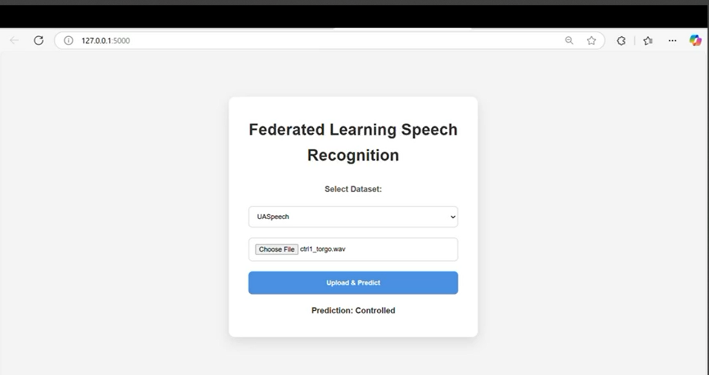
Figure 10.1: UASpeech_Controlled_Result
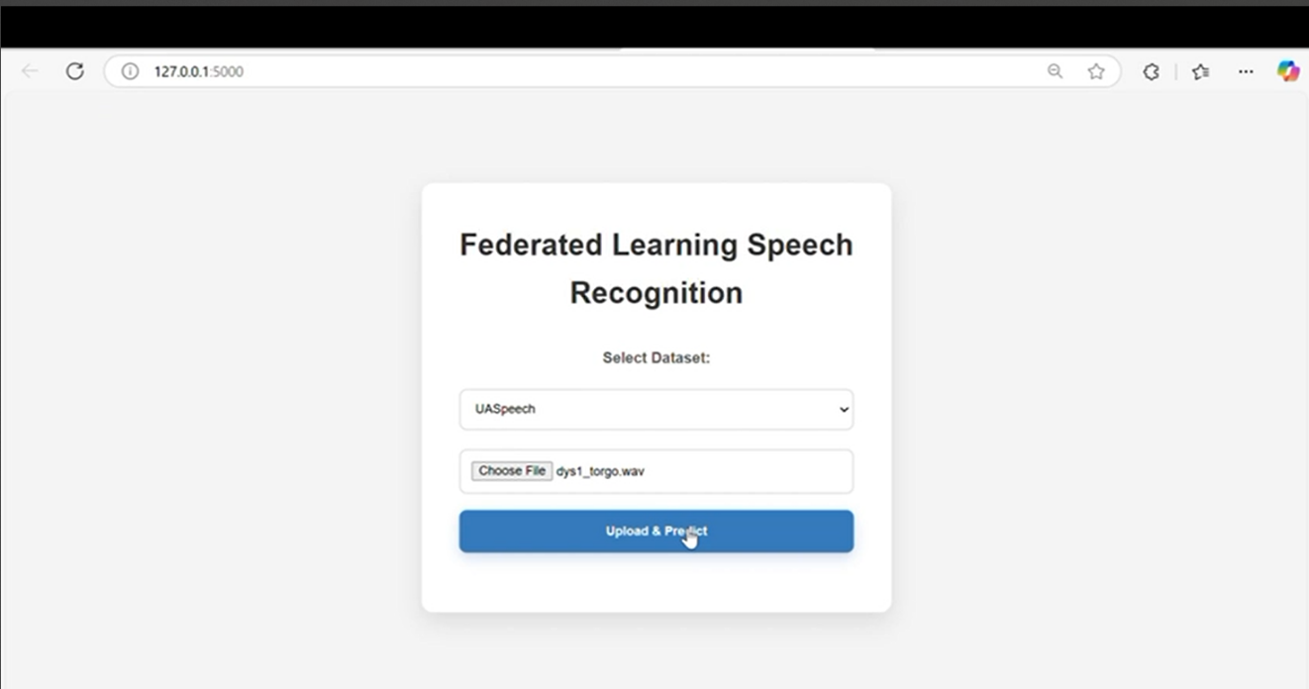
Figure 10.2: UASpeech_Dysarthria_Uploading
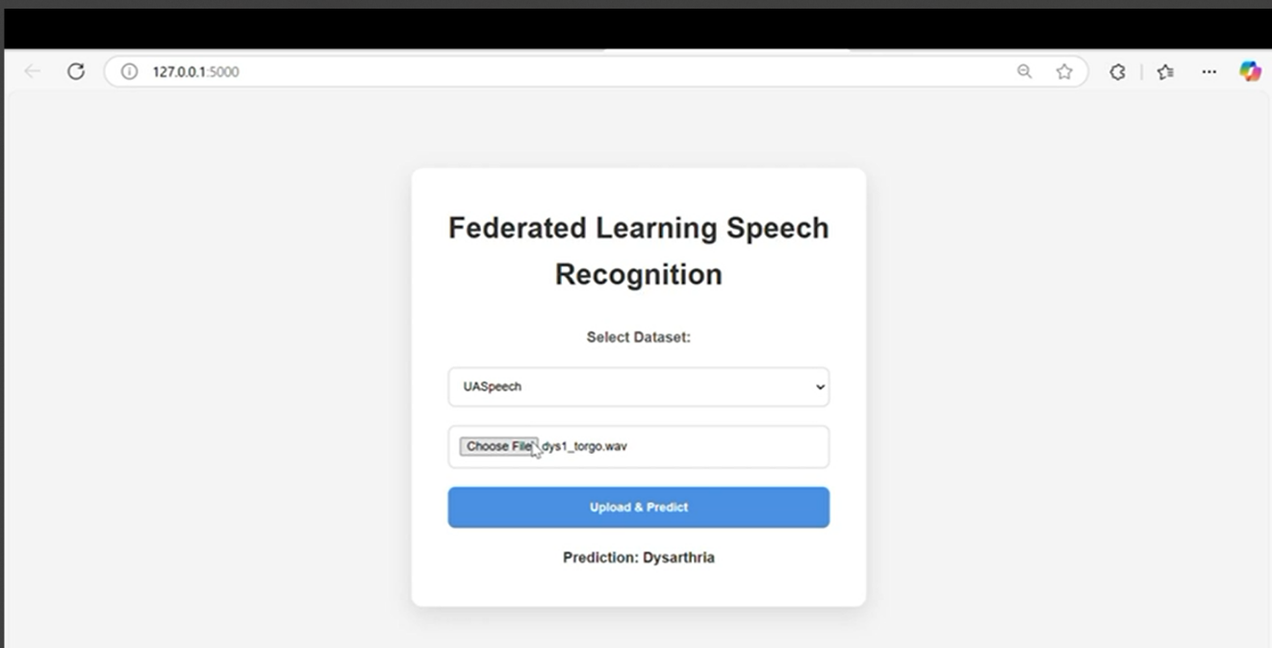
Figure 10.3: UASpeech_Dysarthria_Result
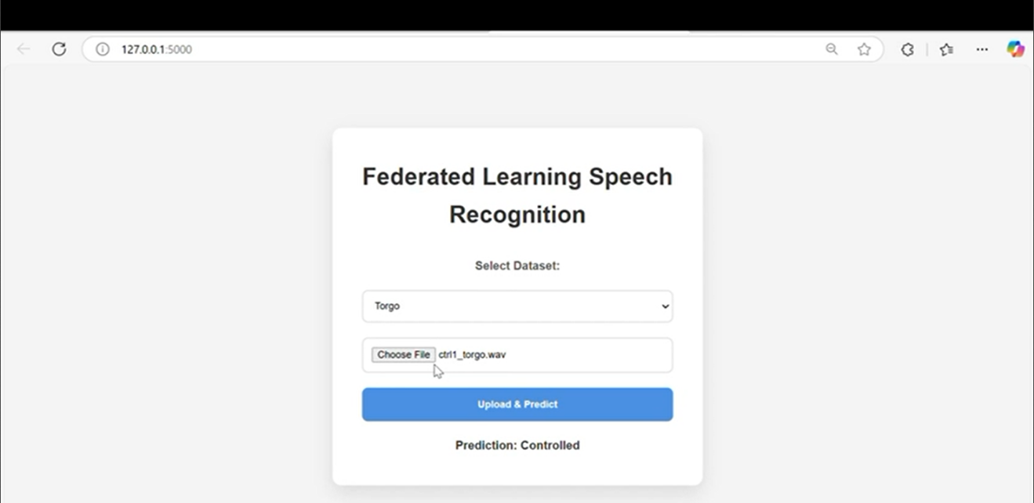
Figure 10.4: Torgo_Controlled_Result

